

**CAPSTONE PROJECT REPORT**

**Report 3 – Software Requirement Specification**

– Hanoi, January 25, 2021 –

**Table of Contents**

I. Project Report **6**

1. Status Report 6

2. Team Involvements 6

3. Issues/Suggestions 6

II. Software Requirement Specification **7**

1. Overall Description 7

1.1 Product Overview 7

1.2 Business Rules 7

2. User Requirements 10

2.1 Overview 10

a. Use Case Diagram 10

Admin 10

Guest & Mentee 11

Mentor 12

Staff 13

b. System Actors 13

c. Use Cases List 14

2.2 Use Case Specification 15

2.2.1. Guest 15

2.2.1.1. Sign up 15

2.2.2. Admin 16

2.2.2.1. View dashboard 16

2.2.2.2 View user info 17

2.2.2.3 View mentor info 17

2.2.2.4 View request info 18

2.2.2.5 View Report 19

2.2.2.6 View technology/skill 19

2.2.2.7 Create technology/skill 20

2.2.2.8 Update technology/skill 20

2.2.2.9 Delete technology/skill 21

2.2.2.10 Ban user 22

2.2.2.11 Unban user 23

2.2.2.12 View Question info 23

2.2.2.13 Search mentor 24

2.2.3. Staff 24

2.2.3.1 View point 24

2.2.3.2 Create point 25

2.2.3.3 Update point transaction 26

2.2.3.4 Confirm Register Mentor 27

2.2.4. Mentor 27

2.2.4.1. Register as mentor 27

2.2.4.2. Sign in 28

2.2.4.3. Sign out 29

2.2.4.4. Edit profile 30

2.2.4.5 Call Audio/Video 30

2.2.4.6. Share screen 31

2.2.4.7. Code on IDE 32

2.2.4.8. Matching 32

2.2.5. Mentee 33

2.2.5.1. Sign in 33

2.2.5.2. Sign out 34

2.2.5.3. Change password 34

2.2.5.4. Forgot password 35

2.2.5.5. View profile info 36

2.2.5.6. Edit profile info 36

2.2.5.7. View Dashboard 37

2.2.5.8. Create Question 38

2.2.5.9. View list created question 38

2.2.5.10 Payment Method 39

2.2.5.11 View list notification 39

2.2.5.12 Join Session room with Mentor 40

2.2.5.13. Rate Mentor 41

2.2.5.14 Report Mentor 42

2.2.5.15 View list favorite Mentor 42

2.2.5.16 View point in transaction 43

2.2.5.17 View point out transaction 44

2.2.5.18 Delete question 44

2.2.5.19 Update question 45

3. Functional Requirements 46

3.1 System Functional Overview 46

a. Screen Flow 46

b. Screen Details 46

c. Screen Authorization 47

d. Non-Screen Functions 49

e. Entity Relationship Diagram 49

3.2 Home 50

a. Sign in 50

b. Manage Skills 51

c. Create Request 52

e. Session 53

f. Matching 54

g. View All Mentor 55

h. View All Category 56

3.3 User Setting 56

a. User Profile 56

b. Register as Mentor 57

c. View All Category 58

3.4 Mentor Info 59

a. Profile CV 59

b. View Comment and Rating of User 59

3.5 Manage Mentee 60

a. Manage Mentee 60

b. View Mentee Info 61

3.6 Manage Mentor 62

a. Manage Mentor 62

b. View Mentor Info 62

3.7 Dashboard 63

a. View List Created Request 63

3.8 Join Session Room 64

a. Share screen 64

b. Call Audio/Video 65

c. Code on IDE 66

a. Chat Box 67

3.6 Register 68

4. Non-Functional Requirements 69

4.1 External Interfaces 69

a. User Interfaces 69

b. Software Interfaces 69

c. Hardware Interfaces 70

d. Communications Interfaces 70

4.2 Quality Attributes 70

a. Usability 70

b. Reliability 71

c. Performance 71

d. Dependability 72

d1. Security 72

d2. Safety 73

e. Supportability 73

f. Design Constraints 73

g. Support Documents 73

5. Other Requirements 73

5.1 Appendix1 - Notification List 73

# I. Project Report

## 1. Status Report

| **#** | **Work Item** | **Status** | **Notes (Work Item in Details)** |
| --- | --- | --- | --- |
| 1 | Overall Description | Completed |  |
| 2 | User Requirements | Completed |  |
| 3 | Functional Requirements | Completed |  |
| 4 | Non-functional requirements | Completed |  |
| 5 | Other Requirements | Completed |  |

## 2. Team Involvements

| **#** | **Task** | **Member** | **Notes (Task Details, etc.)** |
| --- | --- | --- | --- |
| 1 | Overall Description | NghiaHC |  |
| 2 | User Requirements | NghiaHC |  |
| 3 | Functional Requirements | NghiaHC, AnhBC, DatLT |  |
| 4 | Non-functional requirements | NghiaHC |  |
| 5 | Other Requirements | NghiaHC |  |

## 3. Issues/Suggestions

| **#** | **Issue** | **Status** | **Notes (Solution, Suggestion, etc.)** |
| --- | --- | --- | --- |
| 1 |  | Pending |  |
| 2 |  | In Progress |  |
| 3 |  | Completed |  |

# II. Software Requirement Specification

## 1. Overall Description

### 1.1 Product Overview

Nowadays, Information Technology is a very hot major, which is the goal of many students worldwide. But it’s not easy to approach. A lot of students tried hard to study but still did not get a good result.

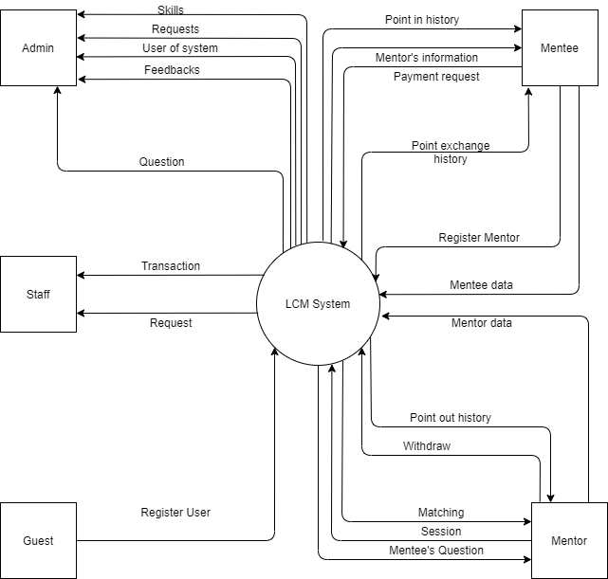

So along with the development of the internet, this project will bring good mentors to students who need to improve their coding skills. Ask and answer in real-time. Everything you think hard will come easier when you can ask someone who already knows about it.

### 1.2 Business Rules

| **ID** | **Description** |
| --- | --- |
| B01 | The email address must be valid |
| B02 | Password must be at least 8 characters in length |
| B03 | Password must be encrypted |
| B04 | When registering or changing a password, a user must enter the new password twice |
| B05 | A guest cannot register with a username and email that has already been registered |
| B06 | User must provide their username or email and password when logging into the website |
| B07 | The access token must be encrypted when saving into the browser’s storage |
| B08 | JWT token is expired in 1 day |
| B09 | User cannot update their username and email once it has been registered |
| B10 | When changing a password, a new password must not be the same as the current password |
| B11 | A user must belong to one of the three roles: Mentee, Mentor, and Admin |
| B12 | When an account is registered, the initial role of the account is Mentee |
| B13 | When an account is registered, the initial role of the account is Mentee |
| B14 | When mentor unregisters mentor, the role of a mentor becomes Mentee |
| B15 | The deadline of request when creating or updating must be in the future |
| B16 | User can only choose 3 types of skill for each request |
| B17 | The price must be at least 10.000 VND |
| B18 | After creating or re-opening, the status of a request is OPEN |
| B19 | After closing, the status of a request is CLOSE |
| B20 | The mentee can only update request, close request, invite mentor, accept or reject waiting for mentors when request’s status is OPEN |
| B21 | The mentee can only reopen the request when the request’s status is CLOSE |
| B22 | The mentor can only accept the request when the request’s status is OPEN |
| B23 | The mentee can only be matching a mentor if having enough money |
| B24 | When mentee accepts mentor, the mentee can chat with the mentor, request’s status is changed to DOING, other waiting mentors will be rejected |
| B25 | When the mentee confirms the request finished, the mentor can take the money of request, request’s status is changed to COMPLETED |
| B26 | When the mentee confirms the request is not finished, the mentor will have a notification to confirm again. If the mentor confirms not finished, back money to the mentee, the status of the request is changed to OPEN. Otherwise, the admin will resolve the conflict. |
| B27 | The only mentor can withdraw money |
| B28 | The mentor can only withdraw with the amount of money less than or equal to the current income |
| B29 | The only mentor can create a bank card |
| B30 | The bank card number must be unique |
| B31 | All lists must be displayed with the pagination |
| B32 | Only display the information of mentors that havan The menteeOne an active status |
| B33 | Only display the information of requests that are within the deadline in list public requests |
| B34 | Chat with admin function only displays in home page |

## 2. User Requirements

### 2.1 Overview

#### a. Use Case Diagram

##### Admin

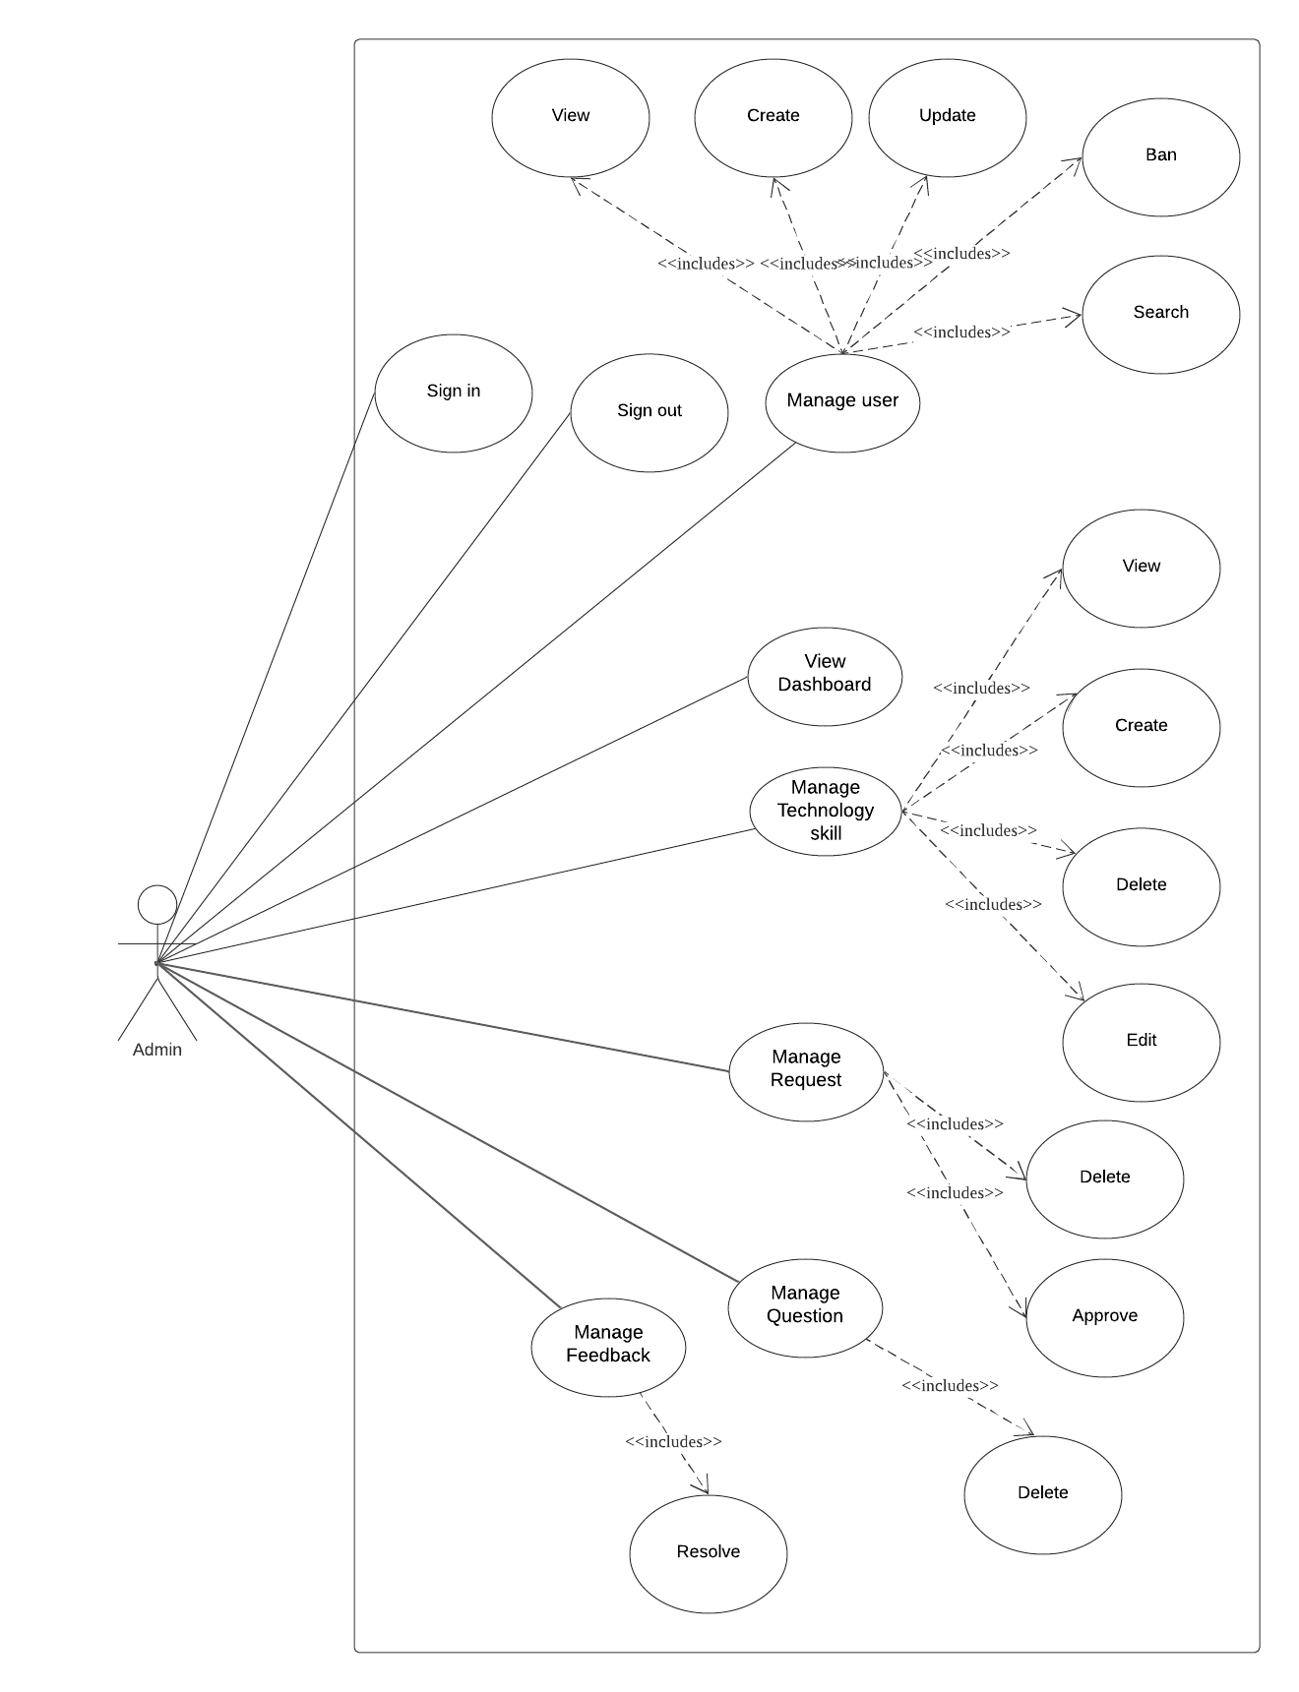

##### Guest & Mentee

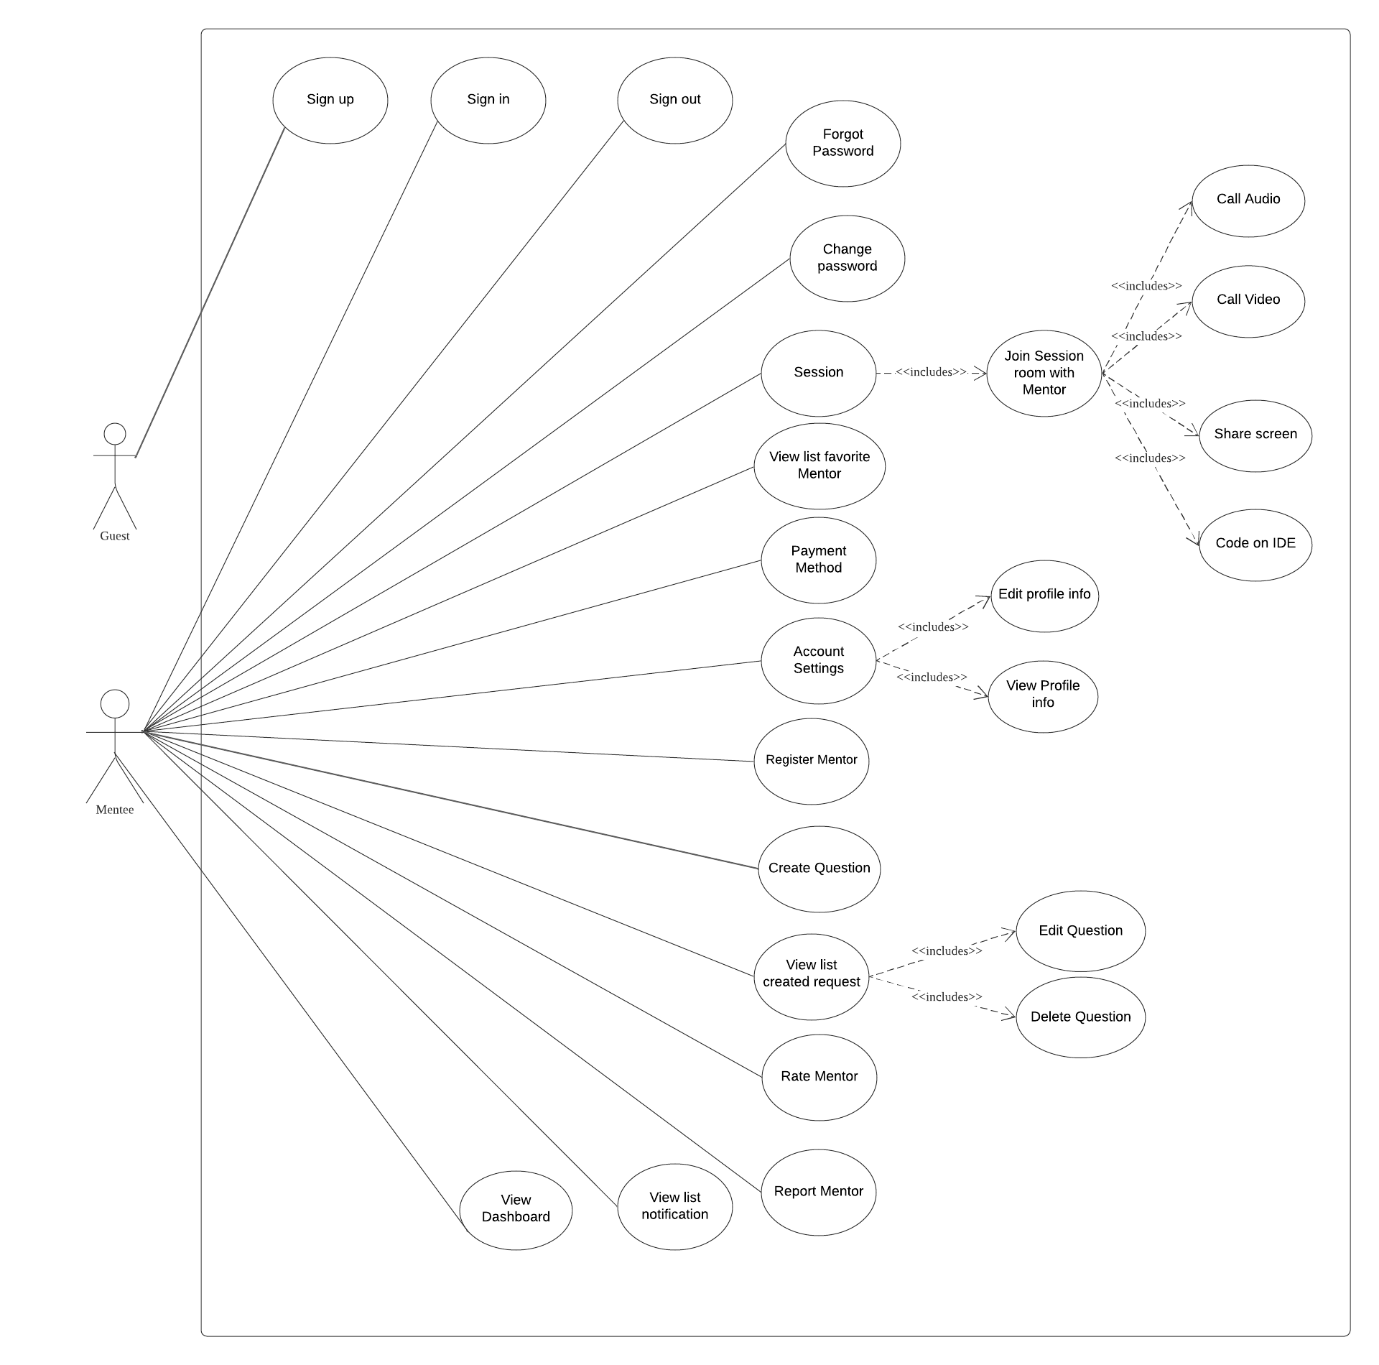

##### Mentor

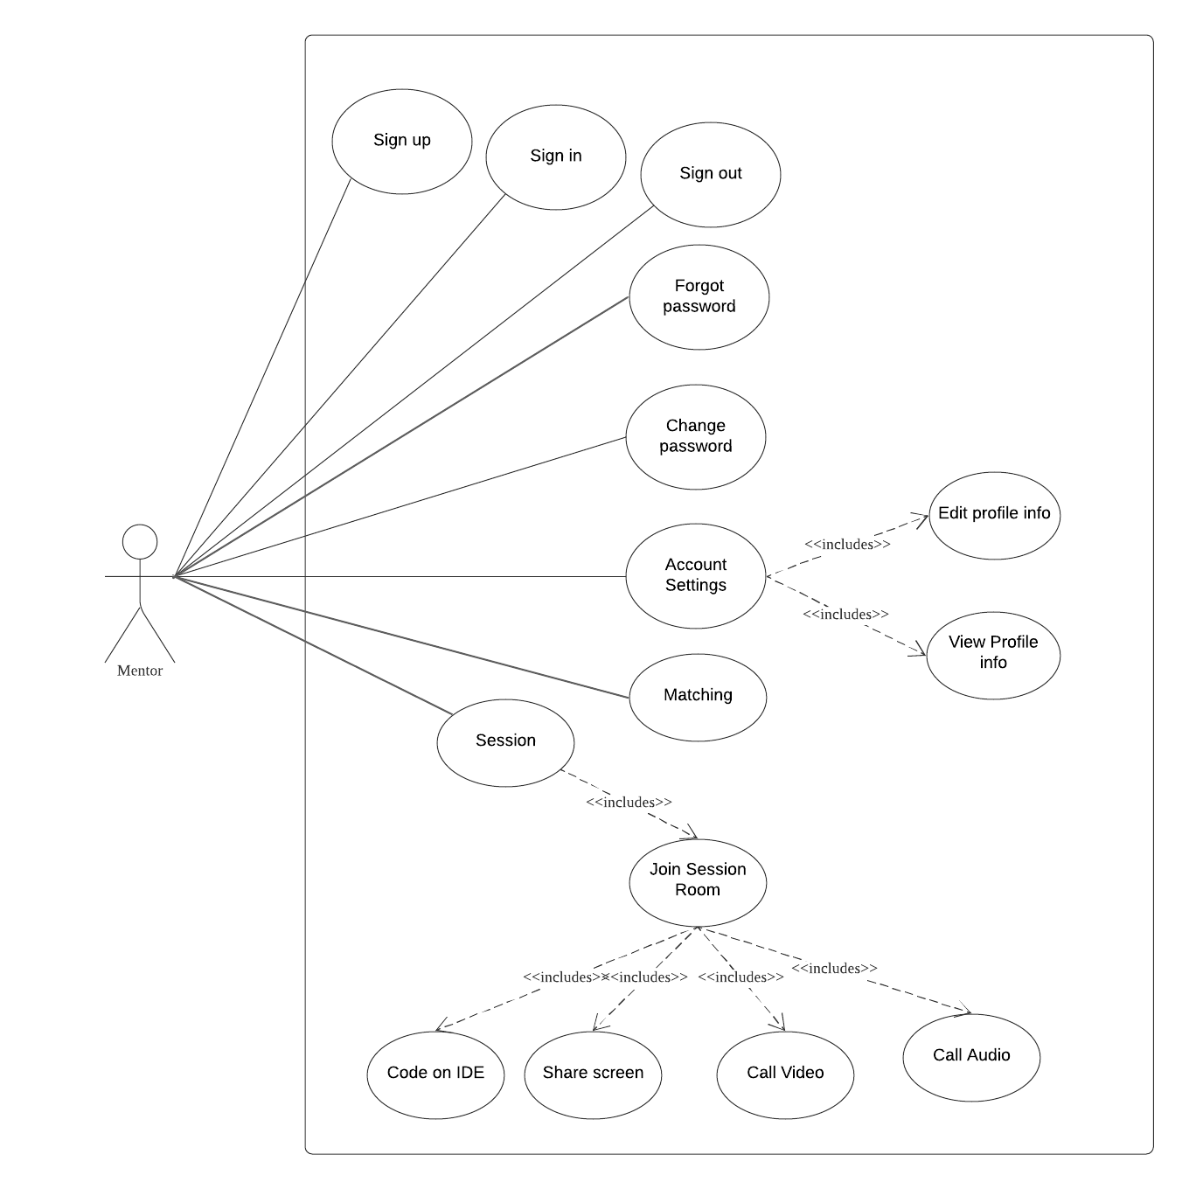

##### Staff

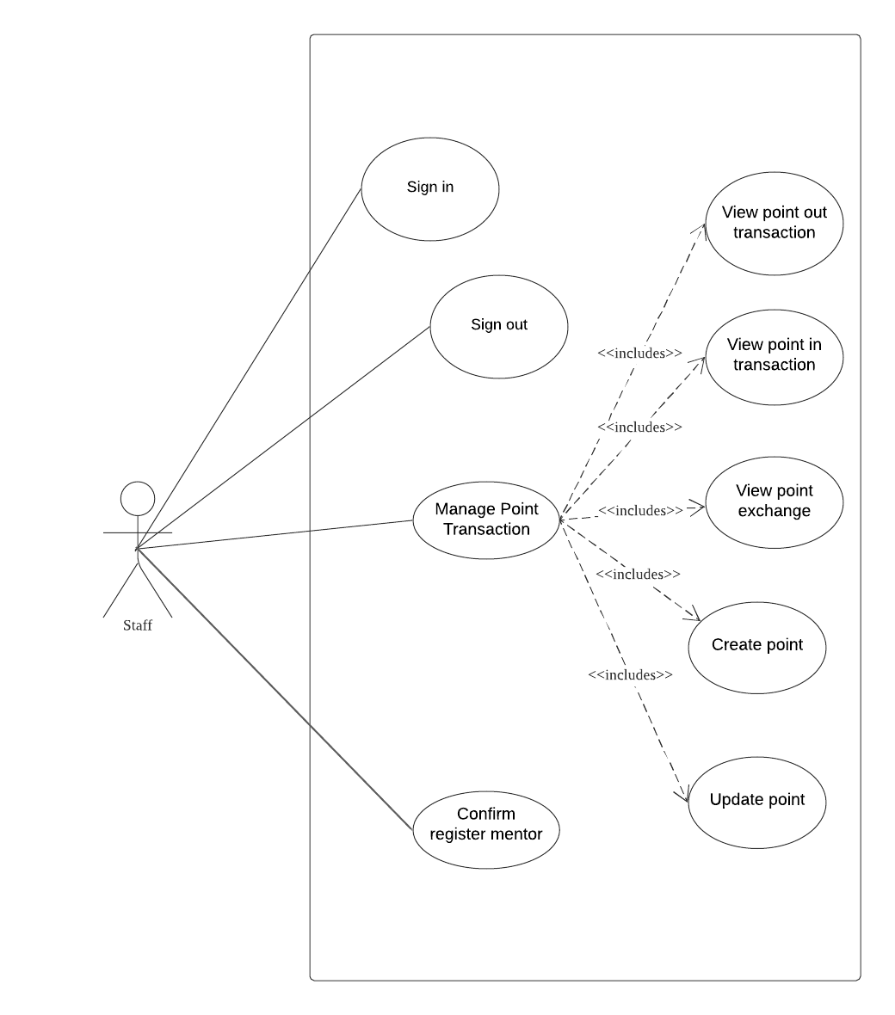

#### b. System Actors

| **#** | **Actors** | **Description** |
| --- | --- | --- |
| 1 | Admin | People who manage the LCM System |
| 2 | Guest | The user that has not yet registered an account |
| 3 | Mentee | The registered user wishes to hire mentors |
| 4 | Mentor | Mentors of LCM System |
| 5 | Staff | People who work the LCM System |

#### c. Use Cases List

| **ID** | **Use Case** | **Primary Actors** | **Secondary Actor** |
| --- | --- | --- | --- |
| UC-01 | Sign up | Guest | N/A |
| UC-02 | View dashboard | Admin | N/A |
| UC-03 | View user info | Admin | N/A |
| UC-04 | View mentor info | Admin | f |
| UC-05 | View request info | Admin | N/A |
| UC-06 | View Report | Admin | N/A |
| UC-07 | View technology/skill | Admin | N/A |
| UC-08 | Create technology/skill | Admin | N/A |
| UC-09 | Update technology/skill | Admin | N/A |
| UC-10 | Delete technology/skill | Admin | N/A |
| UC-11 | Ban User | Admin | N/A |
| UC-12 | Unban User | Admin | N/A |
| UC-13 | View Question Info | Admin | N/A |
| UC-14 | Search Mentor | Admin | N/A |
| UC-15 | View Point | Staff | N/A |
| UC-16 | Create Point | Staff | N/A |
| UC-17 | Update Point Transaction | Staff | N/A |
| UC-18 | Confirm Register Mentor | Staff | N/A |
| UC-19 | Registered as mentor | Mentor | N/A |
| UC-20 | Sign in | Mentor | N/A |
| UC-21 | Sign out | Mentor | N/A |
| UC-22 | Edit profile | Mentor | N/A |
| UC-23 | Call Audio/Video | Mentor | User |
| UC-24 | Share screen | Mentor | User |
| UC-25 | Code on IDE | Mentor | User |
| UC-26 | Matching | Mentor | N/A |
| UC-27 | Sign in | Mentee | N/A |
| UC-28 | Sign out | Mentee | N/A |
| UC-29 | Change password | Mentee | N/A |
| UC-30 | Forgot Password | Mentee | N/A |
| UC-31 | View Profile info | Mentee | N/A |
| UC-32 | Edit profile info | Mentee | N/A |
| UC-33 | View Dashboard | Mentee | N/A |
| UC-34 | Create Question | Mentee | N/A |
| UC-35 | View List Created Question | Mentee | N/A |
| UC-36 | Payment Method | Mentee | N/A |
| UC-37 | View list notification | Mentee | N/A |
| UC-38 | Join Session room with Mentor | Mentee | N/A |
| UC-39 | Rate Mentor | Mentee | N/A |
| UC-40 | Report Mentor | Mentee | N/A |
| UC-41 | View list favorite Mentor | Mentee | N/A |
| UC-42 | View Point In Transaction | Mentee | Staff |
| UC-43 | View Point Out Transaction | Mentee | Staff |
| UC-44 | Delete Question | Mentee | N/A |
| UC-45 | Update Question | Mentee | N/A |

### 2.2 Use Case Specification

#### 2.2.1. Guest

##### 2.2.1.1. Sign up

| **Use Case ID** | UC - 01 | **Use Case Name** | Sign up |
| --- | --- | --- | --- |
| **Created By** | Lê Thành Đạt | **Created Date** | 25/01/2021 |
| **Primary Actor** | Guest | **Secondary Actor** | User |
| **Description** | Sign up for an account on the system. | | |
| **Pre-conditions** | N/A | | |
| **Post-conditions** | When the normal flow completes successfully, a new account will be created with the role of mentee and saved into a database. | | |
| **Normal Flow** | 1. Go to the Home Page. 2. Click “Đăng ký”. 3. System displays “Đăng ký” form. 4. Input full name, username, email, password, re-password. 5. Clicks “Đăng ký” button. 6. System displays a toast success message. 7. Redirect to Login Screen. | | |
| **Alternative Flow** | N/A | | |
| **Exceptions** | The system displays an error message when:   1. Not input all fields in “Đăng kí” form. 2. Username or Email existed. 3. Cannot connect to the server. | | |
| **Priority** | Medium | | |
| **Frequency of Use** | Medium | | |
| **Business Rules** |  | | |
| **Other Information** | N/A | | |
| **Assumptions** | N/A | | |

#### 2.2.2. Admin

##### 2.2.2.1. View dashboard

| **Use Case ID** | UC - 02 | **Use Case Name** | View dashboard |
| --- | --- | --- | --- |
| **Created By** | Lê Thành Đạt | **Created Date** | 25/01/2021 |
| **Primary Actor** | Admin | **Secondary Actor** | N/A |
| **Description** | View dashboard screen about general information. | | |
| **Pre-conditions** | Admin has signed into the admin website. | | |
| **Post-conditions** | N/A | | |
| **Normal Flow** | 1. Go to the Admin Page. 2. Click on “Dashboard” on the sidebar. 3. The system displays all number of mentees, number of questions in a month, number of mentors, number of skills, list all skills, list of questions, list of the mentee, list of the mentors. | | |
| **Alternative Flow** | N/A | | |
| **Exceptions** | The system displays an error message when:   1. Cannot connect to the server. | | |
| **Priority** | High | | |
| **Frequency of Use** | High | | |
| **Business Rules** |  | | |
| **Other Information** | N/A | | |
| **Assumptions** | N/A | | |

##### 2.2.2.2 View user info

| **Use Case ID** | UC – 03 | **Use Case Name** | View user info |
| --- | --- | --- | --- |
| **Created By** | Lê Thành Đạt | **Created Date** | 25/01/2021 |
| **Primary Actor** | Admin | **Secondary Actor** | N/A |
| **Description** | View information of all registered users in the system. | | |
| **Pre-conditions** | Admin has signed into the admin website. | | |
| **Post-conditions** | N/A | | |
| **Normal Flow** | 1. Go to the Admin Page. 2. Click on “Quản lý mentee” on the sidebar. 3. The system displays a list of all mentees with email, role, and action. 4. Admin click the mentee name, the system displays all the information of registered users. | | |
| **Alternative Flow** | N/A | | |
| **Exceptions** | The system displays an error message when:   1. Cannot connect to the server. | | |
| **Priority** | High | | |
| **Frequency of Use** | High | | |
| **Business Rules** |  | | |
| **Other Information** | N/A | | |
| **Assumptions** | N/A | | |

##### 2.2.2.3 View mentor info

| **Use Case ID** | UC – 04 | **Use Case Name** | View mentor info |
| --- | --- | --- | --- |
| **Created By** | Lê Thành Đạt | **Created Date** | 25/01/2021 |
| **Primary Actor** | Admin | **Secondary Actor** | N/A |
| **Description** | View information of all registered mentors in the system. | | |
| **Pre-conditions** | Admin has signed into the admin website. | | |
| **Post-conditions** | N/A | | |
| **Normal Flow** | 1. Go to the Admin Page. 2. Click on “Quản lý mentor” on the sidebar. 3. The system displays a list of all mentees with email, role, and action. 4. Admin click mentor name, the system displays all the information of registered users, rate. | | |
| **Alternative Flow** | N/A | | |
| **Exceptions** | The system displays an error message when:   1. Cannot connect to the server. | | |
| **Priority** | High | | |
| **Frequency of Use** | High | | |
| **Business Rules** |  | | |
| **Other Information** | N/A | | |
| **Assumptions** | N/A | | |

##### 2.2.2.4 View request info

| **Use Case ID** | UC – 05 | **Use Case Name** | View request info |
| --- | --- | --- | --- |
| **Created By** | Lê Thành Đạt | **Created Date** | 25/01/2021 |
| **Primary Actor** | Admin | **Secondary Actor** | N/A |
| **Description** | View all requests in the system | | |
| **Pre-conditions** | Admin has signed into the admin website. | | |
| **Post-conditions** | N/A | | |
| **Normal Flow** | 1. Go to Admin Page 2. Click “Quản lý yêu cầu” in sidebar 3. The system displays all the information of existing requests in the system. | | |
| **Alternative Flow** | N/A | | |
| **Exceptions** | The system displays an error message when:   1. Cannot connect to the server. | | |
| **Priority** | High | | |
| **Frequency of Use** | High | | |
| **Business Rules** |  | | |
| **Other Information** | N/A | | |
| **Assumptions** | N/A | | |

##### 2.2.2.5 View Report

| **Use Case ID** | UC – 06 | **Use Case Name** | View Report |
| --- | --- | --- | --- |
| **Created By** | Lê Thành Đạt | **Created Date** | 25/01/2021 |
| **Primary Actor** | Admin | **Secondary Actor** | N/A |
| **Description** | View all requests in the system. | | |
| **Pre-conditions** | 1. Admin has signed into the admin website. 2. Having at least 1 conflict request on the system. | | |
| **Post-conditions** | When the normal flow completes successfully, the request will be updated in the database. | | |
| **Normal Flow** | 1. Go to Admin Page 2. Click “Quản lý feedback” in sidebar 3. The system displays all the information of existing requests in the system 4. Select Report. 5. Click “Chấp thuận” button. 6. System displays status in request change “Chưa chấp thuận” to “Chấp thuận”. | | |
| **Alternative Flow** | N/A | | |
| **Exceptions** | The system displays an error message when:   1. Cannot connect to the server. | | |
| **Priority** | High | | |
| **Frequency of Use** | High | | |
| **Business Rules** |  | | |
| **Other Information** | N/A | | |
| **Assumptions** | N/A | | |

##### 2.2.2.6 View technology/skill

| **Use Case ID** | UC – 07 | **Use Case Name** | View technology/skill |
| --- | --- | --- | --- |
| **Created By** | Lê Thành Đạt | **Created Date** | 25/01/2021 |
| **Primary Actor** | Admin | **Secondary Actor** | N/A |
| **Description** | View all requests in the system. | | |
| **Pre-conditions** | Admin has signed into the admin website. | | |
| **Post-conditions** | N/A | | |
| **Normal Flow** | 1. Go to the Admin Page. 2. Click “Quản lý kỹ năng” in sidebar. 3. The system displays all the information of existing technology/skills in the system. | | |
| **Alternative Flow** | N/A | | |
| **Exceptions** | The system displays an error message when:   1. Cannot connect to the server. | | |
| **Priority** | High | | |
| **Frequency of Use** | High | | |
| **Business Rules** |  | | |
| **Other Information** | N/A | | |
| **Assumptions** | N/A | | |

##### 2.2.2.7 Create technology/skill

| **Use Case ID** | UC – 08 | **Use Case Name** | Create technology/skill |
| --- | --- | --- | --- |
| **Created By** | Lê Thành Đạt | **Created Date** | 25/01/2021 |
| **Primary Actor** | Admin | **Secondary Actor** | N/A |
| **Description** | View all requests in the system. | | |
| **Pre-conditions** | Admin has signed into the admin website. | | |
| **Post-conditions** | When the normal flow completes successfully, the new skill will be saved into the database. | | |
| **Normal Flow** | 1. Go to the Admin Page. 2. Click “Quản lý kỹ năng” in sidebar. 3. Input the name of the skill. 4. Click “Thêm” button. | | |
| **Alternative Flow** | N/A | | |
| **Exceptions** | The system displays an error message when:   1. Cannot connect to the server. 2. Duplicate skill name in the system. | | |
| **Priority** | Medium | | |
| **Frequency of Use** | Medium | | |
| **Business Rules** |  | | |
| **Other Information** | N/A | | |
| **Assumptions** | N/A | | |

##### 2.2.2.8 Update technology/skill

| **Use Case ID** | UC – 09 | **Use Case Name** | Update technology/skill |
| --- | --- | --- | --- |
| **Created By** | Lê Thành Đạt | **Created Date** | 25/01/2021 |
| **Primary Actor** | Admin | **Secondary Actor** | N/A |
| **Description** | Update an existing skill. | | |
| **Pre-conditions** | Admin has signed into the admin website. | | |
| **Post-conditions** | When the normal flow completes successfully, the new skill will be saved into the database. | | |
| **Normal Flow** | 1. Go to the Admin Page. 2. Click “Quản lý kỹ năng” in sidebar. 3. Click “Chỉnh sửa” button in 1 skill. 4. Update name of the skill. 5. Click “Cập nhật” button. | | |
| **Alternative Flow** | N/A | | |
| **Exceptions** | The system displays an error message when:   1. Cannot connect to the server. 2. Duplicate skill name in the system. | | |
| **Priority** | High | | |
| **Frequency of Use** | High | | |
| **Business Rules** |  | | |
| **Other Information** | N/A | | |
| **Assumptions** | N/A | | |

##### 2.2.2.9 Delete technology/skill

| **Use Case ID** | UC – 10 | **Use Case Name** | Delete technology/skill |
| --- | --- | --- | --- |
| **Created By** | Lê Thành Đạt | **Created Date** | 25/01/2021 |
| **Primary Actor** | Admin | **Secondary Actor** | N/A |
| **Description** | Delete an existing skill. | | |
| **Pre-conditions** | Admin has signed into the admin website. | | |
| **Post-conditions** | When the normal flow completes successfully, the new skill will be deleted in the database. | | |
| **Normal Flow** | 1. Go to the Admin Page. 2. Click “Quản lý kỹ năng” in sidebar. 3. Click “Xoá” button in 1 skill. 4. Show pop-up confirms to delete skill. 5. Click “Đồng ý” button. | | |
| **Alternative Flow** | 1. Go to the Admin Page. 2. Click “Quản lý kỹ năng” in sidebar. 3. Click “Xoá” button in 1 skill. 4. Show pop-up confirms to delete skill. 5. Click “Huỷ” button. | | |
| **Exceptions** | The system displays an error message when:   1. Cannot connect to the server. | | |
| **Priority** | High | | |
| **Frequency of Use** | High | | |
| **Business Rules** |  | | |
| **Other Information** | N/A | | |
| **Assumptions** | N/A | | |

##### 2.2.2.10 Ban user

| **Use Case ID** | UC - 11 | **Use Case Name** | Ban user |
| --- | --- | --- | --- |
| **Created By** | Bùi Công Ánh | **Created Date** | 25/01/2021 |
| **Primary Actor** | Admin | **Secondary Actor** | N/A |
| **Description** | Admin ban the user if used when the user violates the terms | | |
| **Pre-conditions** | 1. Admin has signed into the admin website. 2. Choose a user admin wants to ban. | | |
| **Post-conditions** | The user who has been banned will not login into the system. | | |
| **Normal Flow** | 1. On the page screen dashboard of admin. 2. Choose “Quản lý mente” in the sidebar. 3. The system displays a list of all users. 4. Admin chooses what user wants to ban. 5. Admin click the “Ban” button. 6. Show pop-up confirm. Choose “Có”. 7. System change “Ban” to “Unban”. | | |
| **Alternative Flow** | 1. On the page screen dashboard of admin. 2. Choose “Quản lý mente” in the sidebar. 3. The system displays a list of all users. 4. Admin chooses what user wants to ban. 5. Admin click the “Ban” button. 6. Show pop-up confirm. Choose “Không”. | | |
| **Exceptions** | The system displays an error message when:   1. Cannot connect to the server. | | |
| **Priority** | Medium | | |
| **Frequency of Use** | Medium | | |
| **Business Rules** |  | | |
| **Other Information** | N/A | | |
| **Assumptions** | N/A | | |

##### 2.2.2.11 Unban user

| **Use Case ID** | UC - 12 | **Use Case Name** | Unban user |
| --- | --- | --- | --- |
| **Created By** | Bùi Công Ánh | **Created Date** | 25/01/2021 |
| **Primary Actor** | Admin | **Secondary Actor** | N/A |
| **Description** | Admin ban the user is used when the user violates the terms | | |
| **Pre-conditions** | 1. Admin has logged into admin website 2. Choose a user admin who wants to unban. | | |
| **Post-conditions** | User has unbanned can login in to use the system | | |
| **Normal Flow** | 1. On the page screen dashboard of admin. 2. Choose “Quản lý mentee” in the sidebar. 3. The system displays a list of all users. 4. Admin chooses what user wants to ban. 5. Admin click the “Unban” button. 6. Show pop-up confirm. Choose “Có”. 7. System change “Unban” to “Ban”. | | |
| **Alternative Flow** | 1. On the page screen dashboard of admin. 2. Choose “Quản lý mentee” in the sidebar. 3. The system displays a list of all users. 4. Admin chooses what user wants to ban. 5. Admin click the “Unban” button. 6. Show pop-up confirm. Choose “Không”. | | |
| **Exceptions** | The system displays an error message when:   1. Cannot connect to the server. | | |
| **Priority** | Medium | | |
| **Frequency of Use** | Medium | | |
| **Business Rules** |  | | |
| **Other Information** | N/A | | |
| **Assumptions** | N/A | | |

##### 2.2.2.12 View Question info

| **Use Case ID** | UC - 13 | **Use Case Name** | View Question Info |
| --- | --- | --- | --- |
| **Created By** | Hoang Cong Nghia | **Created Date** | 25/01/2021 |
| **Primary Actor** | Admin | **Secondary Actor** | N/A |
| **Description** | Admin can view the question's info. | | |
| **Pre-conditions** | Admin has signed into the admin website. | | |
| **Post-conditions** | Admin view match question’s Info. | | |
| **Normal Flow** | 1. On the page screen dashboard of admin. 2. Admin click “Quản lý câu hỏi”. 3. System show list all questions. | | |
| **Alternative Flow** | N/A | | |
| **Exceptions** | N/A | | |
| **Priority** | High | | |
| **Frequency of Use** | High | | |
| **Business Rules** |  | | |
| **Other Information** | N/A | | |
| **Assumptions** | N/A | | |

##### 2.2.2.13 Search mentor

| **Use Case ID** | UC - 14 | **Use Case Name** | Search mentor |
| --- | --- | --- | --- |
| **Created By** | Bùi Công Ánh | **Created Date** | 25/01/2021 |
| **Primary Actor** | Admin | **Secondary Actor** | N/A |
| **Description** | Search mentor on the system. | | |
| **Pre-conditions** | Admin has signed into the admin website. | | |
| **Post-conditions** | Show list name of the mentor. | | |
| **Normal Flow** | 1. On the page screen dashboard of admin. 2. Admin click “Quản lý mentor”. 3. Input text in the search area. 4. Click the search icon. 5. The system displays the result. | | |
| **Alternative Flow** | N/A | | |
| **Exceptions** | The system displays an error message when:   1. Not input text. 2. Cannot connect to the server. | | |
| **Priority** | Medium | | |
| **Frequency of Use** | Medium | | |
| **Business Rules** |  | | |
| **Other Information** | N/A | | |
| **Assumptions** | N/A | | |

#### 2.2.3. Staff

##### 2.2.3.1 View point

| **Use Case ID** | UC – 15 | **Use Case Name** | View Point |
| --- | --- | --- | --- |
| **Created By** | Lê Thành Đạt | **Created Date** | 25/01/2021 |
| **Primary Actor** | Staff | **Secondary Actor** | N/A |
| **Description** | View all point exchange transactions in the system. | | |
| **Pre-conditions** | The staff has signed into the staff website. | | |
| **Post-conditions** | N/A | | |
| **Normal Flow** | 1. Go to Homepage. 2. Click “Quản lý point” in the sidebar. 3. The system displays all the information of existing point exchange transactions in the system. | | |
| **Alternative Flow** | N/A | | |
| **Exceptions** | The system displays an error message when:   1. Cannot connect to the server. | | |
| **Priority** | High | | |
| **Frequency of Use** | High | | |
| **Business Rules** |  | | |
| **Other Information** | N/A | | |
| **Assumptions** | N/A | | |

##### 2.2.3.2 Create point

| **Use Case ID** | UC – 16 | **Use Case Name** | Create Point |
| --- | --- | --- | --- |
| **Created By** | Lê Thành Đạt | **Created Date** | 25/01/2021 |
| **Primary Actor** | Staff | **Secondary Actor** | N/A |
| **Description** | Create money in a transaction for the user. | | |
| **Pre-conditions** | The staff has logged into Staff Website. | | |
| **Post-conditions** | When the normal flow completes successfully, the new point in a transaction will be saved into the database and the current point of the user will be increased by the input amount to buy points. | | |
| **Normal Flow** | 1. Go to Homepage. 2. Click “Quản lý point” in the sidebar. 3. Click “Thêm” of the mentee who wants to create the point. 4. Input amount, point, method. 5. Click “Thêm” button. | | |
| **Alternative Flow** | 1. Go to Homepage. 2. Click “Quản lý point” in the sidebar. 3. Click “Thêm” of the mentee who wants to create the point. 4. Input amount, point, method. 5. Click “Huỷ” button. | | |
| **Exceptions** | The system displays an error message when:   1. Cannot connect to the server. | | |
| **Priority** | High | | |
| **Frequency of Use** | High | | |
| **Business Rules** |  | | |
| **Other Information** | N/A | | |
| **Assumptions** | The user has transferred money through a bank account or e-wallet. | | |

##### 2.2.3.3 Update point transaction

| **Use Case ID** | UC – 17 | **Use Case Name** | Update Point Transaction |
| --- | --- | --- | --- |
| **Created By** | Lê Thành Đạt | **Created Date** | 25/01/2021 |
| **Primary Actor** | Staff | **Secondary Actor** | N/A |
| **Description** | Staff transferred manually the point request to the mentor and updated the status of the transaction on the system. | | |
| **Pre-conditions** | 1. The staff has logged into the Staff Website. 2. A mentor has created a withdrawal request. | | |
| **Post-conditions** | When the normal flow completes successfully, the point-out transaction will be updated to success and saved into the database. | | |
| **Normal Flow** | 1. Go to Homepage. 2. Click “Quản lý point” in the sidebar. 3. Click “Thêm” of the mentee who wants to create the point. 4. Input amount, point, method. 5. Click “Thêm” button. | | |
| **Alternative Flow** | 1. Go to Homepage. 2. Click “Quản lý point” in the sidebar. 3. Click “Thêm” of the mentee who wants to create the point. 4. Input amount, point, method. 5. Click “Huỷ” button. | | |
| **Exceptions** | The system displays an error message when:  1. Cannot connect to the server. | | |
| **Priority** | High | | |
| **Frequency of Use** | High | | |
| **Business Rules** |  | | |
| **Other Information** | N/A | | |
| **Assumptions** | N/A | | |

##### 2.2.3.4 Confirm Register Mentor

| **Use Case ID** | UC - 18 | **Use Case Name** | Confirm Register Mentor |
| --- | --- | --- | --- |
| **Created By** | Bùi Công Ánh | **Created Date** | 25/01/2021 |
| **Primary Actor** | Staff | **Secondary Actor** | N/A |
| **Description** | Staff confirms the user wants to become a mentor in the system. | | |
| **Pre-conditions** | 1. The staff has signed into the staff website. 2. Having at least 1 request from the user wants a registered mentor on the system. | | |
| **Post-conditions** | When the normal flow completes successfully, the new mentor will be saved into the database. | | |
| **Normal Flow** | 1. On page screen dashboard of staff. 2. Staff click to “Quản lý yêu cầu”. 3. Staff click to “Chấp thuận” button. 4. The system change status “Chưa chấp thuận” to “Chấp thuận”. | | |
| **Alternative Flow** | 1. On page screen dashboard of staff. 2. Staff click to “Quản lý yêu cầu”. 3. Staff click to “Xoá” button. 4. The system displays a popup to confirm. 5. The system shows message success. | | |
| **Exceptions** | The system displays an error message when:   1. Cannot connect to the server | | |
| **Priority** | High | | |
| **Frequency of Use** | Medium | | |
| **Business Rules** |  | | |
| **Other Information** | N/A | | |
| **Assumptions** | N/A | | |

#### 2.2.4. Mentor

##### 2.2.4.1. Register as mentor

| **Use Case ID** | UC - 19 | **Use Case Name** | Register as mentor |
| --- | --- | --- | --- |
| **Created By** | Hoang Cong Nghia | **Created Date** | 25/01/2021 |
| **Primary Actor** | Mentor | **Secondary Actor** | N/A |
| **Description** | Sign up to become a mentor | | |
| **Pre-conditions** | N/A | | |
| **Post-conditions** | When the normal flow completes successfully, a new account will be created with the role of mentor and saved into the database. | | |
| **Normal Flow** | 1. On the landing page. 2. Click “Trở thành người hướng dẫn”. 3. System displays “Thông tin cơ bản” form. 4. Input username, password, re-password, full name, email,   phone number, date of birth, gender.   1. Clicks “Tiếp theo” button. 2. System displays “Kỹ năng” form. 3. Input skill, link file CV, link GitHub, Linkedin. 4. Clicks “Tiếp theo” button. 5. System displays “Hoàn tất”. 6. Click “Hoàn tất” button. | | |
| **Alternative Flow** | 1. On the landing page. 2. Click “Trở thành người hướng dẫn”. 3. System displays “Thông tin cơ bản” form. 4. Input username, password, re-password, full name, email,   phone number, date of birth, gender.   1. Clicks “Tiếp theo” button. 2. System displays “Kỹ năng” form. 3. Input skill, link file CV, link GitHub, Linkedin. 4. Clicks “Huỷ” button. 5. The system redirects the register form. | | |
| **Exceptions** | The system displays an error message when:   1. Not input all field in “Thông tin cơ bản”. 2. Not input all fields in “Kỹ năng”. 3. Cannot connect to the server. | | |
| **Priority** | High | | |
| **Frequency of Use** | Medium | | |
| **Business Rules** |  | | |
| **Other Information** | N/A | | |
| **Assumptions** | N/A | | |

##### 2.2.4.2. Sign in

| **Use Case ID** | UC - 20 | **Use Case Name** | Sign in |
| --- | --- | --- | --- |
| **Created By** | Hoang Cong Nghia | **Created Date** | 25/01/2021 |
| **Primary Actor** | Mentor | **Secondary Actor** | N/A |
| **Description** | Sign in to an account using email and password. | | |
| **Pre-conditions** | 1. The mentor can access the system. 2. Mentor has already registered an account. | | |
| **Post-conditions** | The mentor is signed into the system. | | |
| **Normal Flow** | 1. Go to Home Page 2. Click “Đăng nhập”. 3. The system loads the Login page. 4. Mentor enters “Tên tài khoản” and “Mật khẩu”. 5. Mentor clicks "Đăng nhập" button. 6. The system checks your input data. If Mentor entered true, Mentor will be Login successful. 7. The system redirects Mentor to the Home page. | | |
| **Alternative Flow** | N/A | | |
| **Exceptions** | EXC1: At step 4 of normal flow, Mentor leaves “Tên tài khoản” blank, then proceeds to step 5.   1. The system displays the error message "Bạn phải nhập tên tài khoản". 2. The mentor is not signed in.   EXC2: At step 4 of normal flow, Mentor leaves “Mật khẩu” blank, then proceeds to step 5.   1. The system displays the error message “Bạn phải nhập mật khẩu". 2. The mentor is not signed in.   EXC3: At step 4 of normal flow, Mentor enters invalid Login credentials, then proceeds to step 5.   1. The system displays the error message "Sai tên tài khoản hoặc mật khẩu. Vui lòng thử lại” 2. The mentor is not signed in. | | |
| **Priority** | High | | |
| **Frequency of Use** | High | | |
| **Business Rules** |  | | |
| **Other Information** | N/A | | |
| **Assumptions** | N/A | | |

##### 2.2.4.3. Sign out

| **Use Case ID** | UC - 21 | **Use Case Name** | Sign out |
| --- | --- | --- | --- |
| **Created By** | Hoang Cong Nghia | **Created Date** | 25/01/2021 |
| **Primary Actor** | Mentor | **Secondary Actor** | N/A |
| **Description** | Sign out the system. | | |
| **Pre-conditions** | 1. Mentor accesses to the system. 2. The mentor is currently signed in. | | |
| **Post-conditions** | The mentor is signed out of the system. | | |
| **Normal Flow** | 1. On the home page screen, select the menu with the user icon in the upper right corner. 2. Mentor clicks “Đăng xuất”. 3. The system will redirect Mentor to the home page. | | |
| **Alternative Flow** | N/A | | |
| **Exceptions** | N/A | | |
| **Priority** | High | | |
| **Frequency of Use** | High | | |
| **Business Rules** |  | | |
| **Other Information** | N/A | | |
| **Assumptions** | N/A | | |

##### 2.2.4.4. Edit profile

| **Use Case ID** | UC - 22 | **Use Case Name** | Edit profile |
| --- | --- | --- | --- |
| **Created By** | Hoang Cong Nghia | **Created Date** | 25/01/2021 |
| **Primary Actor** | Mentor | **Secondary Actor** | N/A |
| **Description** | Mentor edit profile. | | |
| **Pre-conditions** | 1. Mentor accesses to the system. 2. The mentor is currently Logged in. | | |
| **Post-conditions** | When the normal flow completes successfully, the new information will be updated to success and saved into the database. | | |
| **Normal Flow** | 1. On the home page screen. 2. Mentor clicks “Cài đặt”. 3. The system will redirect Mentor to the profile page. 4. Mentor edit information. 5. Click “Cập nhật”. | | |
| **Alternative Flow** | N/A | | |
| **Exceptions** | The system displays an error message when:   1. Cannot connect to the server. 2. User not input in the edit form. | | |
| **Priority** | Medium | | |
| **Frequency of Use** | High | | |
| **Business Rules** |  | | |
| **Other Information** | N/A | | |
| **Assumptions** | N/A | | |

##### 2.2.4.5 Call Audio/Video

| **Use Case ID** | UC - 23 | **Use Case Name** | Call Audio/Video |
| --- | --- | --- | --- |
| **Created By** | Hoang Cong Nghia | **Created Date** | 26/01/2021 |
| **Primary Actor** | Mentor | **Secondary Actor** | N/A |
| **Description** | Mentor calls Audio/Video with the mentee. | | |
| **Pre-conditions** | 1. The mentor is currently signed in. 2. The mentor must enable a camera and microphone. | | |
| **Post-conditions** | Mentor calls Audio/Video with the mentee. | | |
| **Normal Flow** | 1. On the home page screen. 2. Mentor click “Session” in the sidebar. 3. The system will redirect the mentor to the session room. 4. Click the tab “Audio/Video”. 5. Mentor enables camera and microphone. 6. The system displays the call screen. | | |
| **Alternative Flow** | N/A | | |
| **Exceptions** | EXC1: At step 4 of normal flow, if Mentor doesn’t enable. The system then proceeds to step 5.   1. The mentor cannot call video with the mentee.   EXC2: At step 4 of normal flow, if Mentor doesn’t enable the microphone, then proceeds to step 5.   1. The mentor cannot call audio with the mentee. | | |
| **Priority** | High | | |
| **Frequency of Use** | High | | |
| **Business Rules** |  | | |
| **Other Information** | N/A | | |
| **Assumptions** | N/A | | |

##### 2.2.4.6. Share screen

| **Use Case ID** | UC - 24 | **Use Case Name** | Share screen |
| --- | --- | --- | --- |
| **Created By** | Hoang Cong Nghia | **Created Date** | 26/01/2021 |
| **Primary Actor** | Mentor | **Secondary Actor** | N/A |
| **Description** | Mentor call share screen with the mentee. | | |
| **Pre-conditions** | The mentor must be signed in. | | |
| **Post-conditions** | Mentor shares the screen with the mentee. | | |
| **Normal Flow** | 1. On the home page screen. 2. On the tab “Video/Audio call”. 3. Mentor click “Chia sẻ màn hình”. 4. The system displays the share screen. | | |
| **Alternative Flow** | 1. On the home page screen. 2. On the tab “Video/Audio call”. 3. Mentor click “Dừng chia sẻ màn hình”. 4. System turn of the share screen. | | |
| **Exceptions** | The system displays an error message when:   1. Cannot connect to the server. | | |
| **Priority** | High | | |
| **Frequency of Use** | High | | |
| **Business Rules** |  | | |
| **Other Information** | N/A | | |
| **Assumptions** | N/A | | |

##### 2.2.4.7. Code on IDE

| **Use Case ID** | UC - 25 | **Use Case Name** | Code on IDE |
| --- | --- | --- | --- |
| **Created By** | Hoang Cong Nghia | **Created Date** | 26/01/2021 |
| **Primary Actor** | Mentor | **Secondary Actor** | N/A |
| **Description** | Mentor code collabo with the mentee. | | |
| **Pre-conditions** | The mentor must be signed in. | | |
| **Post-conditions** | Mentor code on IDE with the mentee. | | |
| **Normal Flow** | 1. On the home page screen. 2. On the tab “Real-time Collaborative Editor”. 3. The system displays the collab coding. | | |
| **Alternative Flow** | N/A | | |
| **Exceptions** | The system displays an error message when:   1. Cannot connect to the server. | | |
| **Priority** | High | | |
| **Frequency of Use** | High | | |
| **Business Rules** |  | | |
| **Other Information** | N/A | | |
| **Assumptions** | N/A | | |

##### 2.2.4.8. Matching

| **Use Case ID** | UC - 26 | **Use Case Name** | Matching |
| --- | --- | --- | --- |
| **Created By** | Hoang Cong Nghia | **Created Date** | 26/01/2021 |
| **Primary Actor** | Mentor | **Secondary Actor** | N/A |
| **Description** | Mentor choose questions of mentee by skill. | | |
| **Pre-conditions** | The mentor must be signed in. | | |
| **Post-conditions** | Mentor can join the session of question with the mentee. | | |
| **Normal Flow** | 1. On the home page screen. 2. On the tab “Matching” in the sidebar. 3. Mentors can use mouse then click onto the card and swipe to the right to choose the question. 4. System show pop-up “Đã chọn”. | | |
| **Alternative Flow** | 1. On the home page screen. 2. On tab “Matching” in the sidebar. 3. Mentor can use mouse then click onto the card and swipe to the right to choose the question. 4. System shows another question. | | |
| **Exceptions** | The system displays an error message when:   1. Cannot connect to the server. | | |
| **Priority** | High | | |
| **Frequency of Use** | High | | |
| **Business Rules** |  | | |
| **Other Information** | N/A | | |
| **Assumptions** | N/A | | |

#### 2.2.5. Mentee

##### 2.2.5.1. Sign in

| **Use Case ID** | UC - 27 | **Use Case Name** | Sign in |
| --- | --- | --- | --- |
| **Created By** | Hoang Cong Nghia | **Created Date** | 26/01/2021 |
| **Primary Actor** | Mentee | **Secondary Actor** | N/A |
| **Description** | Mentee sign in to an account using email and password. | | |
| **Pre-conditions** | 1. The mentee can access the system. 2. The mentee has already registered an account. | | |
| **Post-conditions** | 1. The mentee is signed into the system. 2. The mentee is redirected to Homepage. | | |
| **Normal Flow** | 1. Go to Home Page 2. Click “Đăng nhập”. 3. The system loads the sign in page. 4. Mentor enters “Tên tài khoản” and “Mật khẩu”. 5. Mentee clicks "Đăng nhập" button. 6. The system checks your input data. If Mentee entered true, Mentee will be Login successful. 7. The system redirects Mentee to the Home page. | | |
| **Alternative Flow** | N/A | | |
| **Exceptions** | EXC1: At step 4 of normal flow, Mentor leaves “Tên tài khoản” blank, then proceeds to step 5.   1. The system displays the error message "Bạn phải nhập tên tài khoản". 2. The mentor is not signed in.   EXC2: At step 4 of normal flow, Mentor leaves “Mật khẩu” blank, then proceeds to step 5.   1. The system displays the error message “Bạn phải nhập mật khẩu". 2. The mentor is not signed in.   EXC3: At step 4 of normal flow, Mentor enters invalid Login credentials, then proceeds to step 5.   1. The system displays the error message "Sai tên tài khoản hoặc mật khẩu. Vui lòng thử lại” 2. The mentor is not signed in. | | |
| **Priority** | High | | |
| **Frequency of Use** | High | | |
| **Business Rules** |  | | |
| **Other Information** | N/A | | |
| **Assumptions** | N/A | | |

##### 2.2.5.2. Sign out

| **Use Case ID** | UC - 28 | **Use Case Name** | Sign out |
| --- | --- | --- | --- |
| **Created By** | Hoang Cong Nghia | **Created Date** | 25/01/2021 |
| **Primary Actor** | Mentee | **Secondary Actor** | N/A |
| **Description** | Mentee sign out the system. | | |
| **Pre-conditions** | 1. Mentee accesses to the system. 2. The mentee is currently signed in. | | |
| **Post-conditions** | The mentee is signed out of the system. | | |
| **Normal Flow** | 1. On the home page screen, select the menu with the three-tile icon in the upper right corner. 2. Mentee clicks “Đăng xuất”. 3. The system will redirect Mentee to the Home page. | | |
| **Alternative Flow** | N/A | | |
| **Exceptions** | N/A | | |
| **Priority** | High | | |
| **Frequency of Use** | High | | |
| **Business Rules** |  | | |
| **Other Information** | N/A | | |
| **Assumptions** | N/A | | |

##### 2.2.5.3. Change password

| **Use Case ID** | UC - 29 | **Use Case Name** | Change password |
| --- | --- | --- | --- |
| **Created By** | Hoang Cong Nghia | **Created Date** | 26/01/2021 |
| **Primary Actor** | Mentee | **Secondary Actor** | N/A |
| **Description** | Mentee changes their password. | | |
| **Pre-conditions** | The mentee must sign in. | | |
| **Post-conditions** | When the normal flow completes successfully, the new password will be updated to success and saved into the database. | | |
| **Normal Flow** | 1. On the home page screen. 2. Mentee click “Cài đặt” and choose “Cài đặt bảo mật”. 3. Mentee input old password, new password and confirm password. 4. Click “Change password” button. | | |
| **Alternative Flow** | N/A | | |
| **Exceptions** | EXC1: At step 2 of normal flow, if Mentee enter the wrong format   1. The mentee has to enter the password again.   EXC2: At step 3 of normal flow, if Mentee re-enter password doesn’t match the password   1. The mentee has to re-enter the password again. | | |
| **Priority** | High | | |
| **Frequency of Use** | High | | |
| **Business Rules** |  | | |
| **Other Information** | N/A | | |
| **Assumptions** | N/A | | |

##### 2.2.5.4. Forgot password

| **Use Case ID** | UC - 30 | **Use Case Name** | Forgot password |
| --- | --- | --- | --- |
| **Created By** | Hoang Cong Nghia | **Created Date** | 26/01/2021 |
| **Primary Actor** | Mentee | **Secondary Actor** | N/A |
| **Description** | Mentee forgot their password | | |
| **Pre-conditions** | N/A | | |
| **Post-conditions** | Mentee reset their password | | |
| **Normal Flow** | 1. On home gage 2. The system loads the Login page. 3. Click tab “Quên mật khẩu”. 4. Mentee enters Email. 5. Mentee click “Reset”. 6. Mentee enter code reset password sent to email. 7. Mentee set a new password. | | |
| **Alternative Flow** | N/A | | |
| **Exceptions** | EXC1: System display error message when   1. Mentee enters the wrong new password and is sent to email. 2. Mentee set a new password in the wrong format | | |
| **Priority** | High | | |
| **Frequency of Use** | High | | |
| **Business Rules** |  | | |
| **Other Information** | N/A | | |
| **Assumptions** | N/A | | |

##### 2.2.5.5. View profile info

| **Use Case ID** | UC - 31 | **Use Case Name** | View profile info |
| --- | --- | --- | --- |
| **Created By** | Hoang Cong Nghia | **Created Date** | 25/01/2021 |
| **Primary Actor** | Mentee | **Secondary Actor** | N/A |
| **Description** | Mentee view profile info. | | |
| **Pre-conditions** | 1. Mentee accesses to the system. 2. The mentee is currently signed in. | | |
| **Post-conditions** | N/A | | |
| **Normal Flow** | 1. On the home page screen. 2. Mentee clicks “Cài đặt”. 3. The system shows profile information. | | |
| **Alternative Flow** | N/A | | |
| **Exceptions** | The system displays an error message when:  1. Cannot connect to the server. | | |
| **Priority** | Medium | | |
| **Frequency of Use** | High | | |
| **Business Rules** |  | | |
| **Other Information** | N/A | | |
| **Assumptions** | N/A | | |

##### 2.2.5.6. Edit profile info

| **Use Case ID** | UC - 32 | **Use Case Name** | Edit profile info |
| --- | --- | --- | --- |
| **Created By** | Hoang Cong Nghia | **Created Date** | 25/01/2021 |
| **Primary Actor** | Mentee | **Secondary Actor** | N/A |
| **Description** | Mentee edit profile info. | | |
| **Pre-conditions** | 1. Mentee accesses to the system. 2. The mentee is currently signed in. | | |
| **Post-conditions** | When the normal flow completes successfully, the new information will be updated to success and saved into the database. | | |
| **Normal Flow** | 1. On the home page screen. 2. MeThe menteepointsntor clicks “Cài đặt” in the sidebar. 3. The system shows the mentee profile. 4. Mentor edit information. 5. Click “Save”. | | |
| **Alternative Flow** | N/A | | |
| **Exceptions** | The system displays an error message when:  1. Cannot connect to the server. | | |
| **Priority** | Medium | | |
| **Frequency of Use** | High | | |
| **Business Rules** |  | | |
| **Other Information** | N/A | | |
| **Assumptions** | N/A | | |

##### 2.2.5.7. View Dashboard

| **Use Case ID** | UC - 33 | **Use Case Name** | View Dashboard |
| --- | --- | --- | --- |
| **Created By** | Hoang Cong Nghia | **Created Date** | 26/01/2021 |
| **Primary Actor** | Mentee | **Secondary Actor** | N/A |
| **Description** | Mentee views their dashboard. | | |
| **Pre-conditions** | 1. Mentee accesses to the system. 2. The mentee is currently signed in. | | |
| **Post-conditions** | N/A | | |
| **Normal Flow** | 1. On the “Home page” screen. 2. Mentee click “Dashboard”. 3. The system will show the point, number question of the month, favorite mentor. | | |
| **Alternative Flow** | N/A | | |
| **Exceptions** | N/A | | |
| **Priority** | High | | |
| **Frequency of Use** | High | | |
| **Business Rules** |  | | |
| **Other Information** | N/A | | |
| **Assumptions** | N/A | | |

##### 2.2.5.8. Create Question

| **Use Case ID** | UC - 34 | **Use Case Name** | Create Question |
| --- | --- | --- | --- |
| **Created By** | Bùi Công Ánh | **Created Date** | 25/01/2021 |
| **Primary Actor** | Mentee | **Secondary Actor** | N/A |
| **Description** | Create a question on the system | | |
| **Pre-conditions** | 1. Mentee accesses to the system. 2. The mentee is currently signed in. | | |
| **Post-conditions** | When the normal flow completes successfully, the created question will be saved into the database with the status “New”. | | |
| **Normal Flow** | 1. On the mentee home screen. 2. Mentee chooses “Thêm câu hỏi” on the left screen. 3. Input form of a question. 4. Click “Xác nhận” button. 5. The system displays a success message. 6. The system redirects to the detail screen of that created request. | | |
| **Alternative Flow** | N/A | | |
| **Exceptions** | The system displays an error message when:   1. Not input title, content and not choose skill language, time available, point. 2. Cannot connect to the server | | |
| **Priority** | High | | |
| **Frequency of Use** | High | | |
| **Business Rules** |  | | |
| **Other Information** | N/A | | |
| **Assumptions** | N/A | | |

##### 2.2.5.9. View list created question

| **Use Case ID** | UC - 35 | **Use Case Name** | View list created question |
| --- | --- | --- | --- |
| **Created By** | Bùi Công Ánh | **Created Date** | 25/01/2021 |
| **Primary Actor** | Mentee | **Secondary Actor** | N/A |
| **Description** | View list created question | | |
| **Pre-conditions** | 1. Mentee accesses to the system. 2. The mentee is currently signed in. | | |
| **Post-conditions** | N/A | | |
| **Normal Flow** | 1. On the mentee home screen. 2. Mentee choose tab “Danh sách câu hỏi”. 3. Show list all questions has a title, status, point of the question. | | |
| **Alternative Flow** | N/A | | |
| **Exceptions** | The system displays an error message when:   1. Cannot connect to the server | | |
| **Priority** | Medium | | |
| **Frequency of Use** | Medium | | |
| **Business Rules** |  | | |
| **Other Information** | N/A | | |
| **Assumptions** | N/A | | |

##### 2.2.5.10 Payment Method

| **Use Case ID** | UC - 36 | **Use Case Name** | Payment Method |
| --- | --- | --- | --- |
| **Created By** | Bùi Công Ánh | **Created Date** | 25/01/2021 |
| **Primary Actor** | Mentee | **Secondary Actor** | N/A |
| **Description** | The mentee can add a point to the account. | | |
| **Pre-conditions** | 1. Mentee accesses to the system. 2. The mentee is currently signed in. | | |
| **Post-conditions** | When the normal flow completes successfully, the point of mentee has updated in the database. | | |
| **Normal Flow** | 1. On the mentee home screen. 2. Choose the tab “Thanh toán” in the sidebar. 3. The system displays form input card payment. 4. Mentee input card information. 5. Click “Thanh toán” button. 6. The system displays the success message. | | |
| **Alternative Flow** | N/A | | |
| **Exceptions** | The system displays an error message when:   1. Cannot connect to the server. 2. Card payment is not correct. | | |
| **Priority** | High | | |
| **Frequency of Use** | Medium | | |
| **Business Rules** |  | | |
| **Other Information** | N/A | | |
| **Assumptions** | N/A | | |

##### 2.2.5.11 View list notification

| **Use Case ID** | UC - 37 | **Use Case Name** | View list notification |
| --- | --- | --- | --- |
| **Created By** | Bùi Công Ánh | **Created Date** | 25/01/2021 |
| **Primary Actor** | Mentee | **Secondary Actor** | N/A |
| **Description** | View list all notification | | |
| **Pre-conditions** | 1. Mentee accesses to the system. 2. The mentee is currently signed in. | | |
| **Post-conditions** | N/A | | |
| **Normal Flow** | 1. Click “Thông báo” icon in the top header. 2. The system displays all notifications. | | |
| **Alternative Flow** | N/A | | |
| **Exceptions** | The system displays an error message when:   1. Cannot connect to the server | | |
| **Priority** | High | | |
| **Frequency of Use** | Medium | | |
| **Business Rules** |  | | |
| **Other Information** | N/A | | |
| **Assumptions** | N/A | | |

##### 2.2.5.12 Join Session room with Mentor

| **Use Case ID** | UC - 38 | **Use Case Name** | Join Session room with Mentor |
| --- | --- | --- | --- |
| **Created By** | Bùi Công Ánh | **Created Date** | 25/01/2021 |
| **Primary Actor** | Mentee | **Secondary Actor** | N/A |
| **Description** | Join session room with Mentor | | |
| **Pre-conditions** | 1. The mentee is currently signed in. 2. The mentee has created a request. 3. The status of a request is OPEN. | | |
| **Post-conditions** | Credits will be automatically applied when Mentee start a session | | |
| **Normal Flow** | 1. On the mentee home screen. 2. Choose tab “Session”. 3. System displays all sessions. 4. Click “Vào session” button 5. The system moves the mentee to a room with the mentor and starts a session | | |
| **Alternative Flow** | N/A | | |
| **Exceptions** | The system displays an error message when:   1. Cannot connect to the server. 2. Mentee does not have enough money. | | |
| **Priority** | High | | |
| **Frequency of Use** | High | | |
| **Business Rules** |  | | |
| **Other Information** | N/A | | |
| **Assumptions** | N/A | | |

##### 2.2.5.13. Rate Mentor

| **Use Case ID** | UC - 39 | **Use Case Name** | Rate Mentor |
| --- | --- | --- | --- |
| **Created By** | Bùi Công Ánh | **Created Date** | 25/01/2021 |
| **Primary Actor** | Mentee | **Secondary Actor** | N/A |
| **Description** | Comment and rate mentor after finishing request | | |
| **Pre-conditions** | 1. The mentee is currently signed in. 2. The mentee has created a request. 3. The mentee has a request with the status is DOING | | |
| **Post-conditions** | When the normal flow completes successfully, Mentor can receive the money of request and the comment and rating for that mentor will be saved into a database | | |
| **Normal Flow** | 1. On the session screen. 2. Click “Hoàn thành” button. 3. The system displays a form to comment and rating mentors. 4. Input comment and select rating for Mentor. 5. Click “Xác nhận đánh giá” button. 6. The system sends notifications and mail to Mentor. 7. The request’s status is changed to COMPLETE | | |
| **Alternative Flow** | 1. Go to mentee own request detail screen 2. Click “Không hoàn thành” button 3. The system displays a form to comment and rating mentor 4. Input comment and select rating for Mentor 5. Click “Xác nhận đánh giá” button 6. The system sends notification and mail to Mentor 7. The request’s status is changed to CLOSE | | |
| **Exceptions** | The system displays an error message when:   1. Cannot connect to the server 2. Mentee does not have enough money | | |
| **Priority** | High | | |
| **Frequency of Use** | High | | |
| **Business Rules** |  | | |
| **Other Information** | N/A | | |
| **Assumptions** | N/A | | |

##### 2.2.5.14 Report Mentor

| **Use Case ID** | UC - 40 | **Use Case Name** | Report Mentor |
| --- | --- | --- | --- |
| **Created By** | Bùi Công Ánh | **Created Date** | 25/01/2021 |
| **Primary Actor** | Mentee | **Secondary Actor** | N/A |
| **Description** | Report mentor after finishing request | | |
| **Pre-conditions** | 1. The mentee is currently signed in. 2. The mentee has created a request. 3. The mentee has a request with the status is DOING | | |
| **Post-conditions** | When the normal flow completes successfully, Mentee can report Mentor of request and the report will be saved into a database | | |
| **Normal Flow** | 1. Go to mentee own request detail screen 2. Click “Báo cáo Mentor” button 3. The system displays a form to report mentor 4. Choose why report mentor 5. Input what happened with Mentor 6. Click “Gửi báo cáo” button 7. The system sends notification and mail to Mentee | | |
| **Alternative Flow** | 1. Go to mentee own request detail screen 2. Click “Báo cáo Mentor” button 3. The system displays a form to report mentor 4. Choose why report mentor 5. Input what happened with Mentor 6. Click “Huỷ” button | | |
| **Exceptions** | The system displays an error message when:   1. Cannot connect to the server | | |
| **Priority** | High | | |
| **Frequency of Use** | High | | |
| **Business Rules** |  | | |
| **Other Information** | N/A | | |
| **Assumptions** | N/A | | |

##### 2.2.5.15 View list favorite Mentor

| **Use Case ID** | UC - 41 | **Use Case Name** | View list favorite Mentor |
| --- | --- | --- | --- |
| **Created By** | Bùi Công Ánh | **Created Date** | 25/01/2021 |
| **Primary Actor** | Mentee | **Secondary Actor** | N/A |
| **Description** | View list favorite mentor | | |
| **Pre-conditions** | 1. The mentee is currently signed in. 2. The mentee has favorited Mentor | | |
| **Post-conditions** | N/A | | |
| **Normal Flow** | 1. On the home screen. 2. Choose tab “Mentor yêu thích” in the sidebar. 3. The system displays all favorite mentor | | |
| **Alternative Flow** | N/A | | |
| **Exceptions** | The system displays an error message when:   1. Cannot connect to the server | | |
| **Priority** | Medium | | |
| **Frequency of Use** | Medium | | |
| **Business Rules** |  | | |
| **Other Information** | N/A | | |
| **Assumptions** | N/A | | |

##### 2.2.5.16 View point in transaction

| **Use Case ID** | UC – 42 | **Use Case Name** | View Point In Transaction |
| --- | --- | --- | --- |
| **Created By** | Lê Thành Đạt | **Created Date** | 25/01/2021 |
| **Primary Actor** | Mentee | **Secondary Actor** | Staff |
| **Description** | View all point in transactions in the system | | |
| **Pre-conditions** | 1. The mentee is currently signed in. | | |
| **Post-conditions** | N/A | | |
| **Normal Flow** | 1. Go to Homepage. 2. Click “Bản tin” in the sidebar. 3. Choose “Quản lý giao dịch”. 4. The system displays all the information of existing points in transactions in the system. | | |
| **Alternative Flow** | N/A | | |
| **Exceptions** | The system displays an error message when:   1. Cannot connect to the server | | |
| **Priority** | High | | |
| **Frequency of Use** | High | | |
| **Business Rules** |  | | |
| **Other Information** | N/A | | |
| **Assumptions** | N/A | | |

##### 2.2.5.17 View point out transaction

| **Use Case ID** | UC – 43 | **Use Case Name** | View point out transaction |
| --- | --- | --- | --- |
| **Created By** | Lê Thành Đạt | **Created Date** | 25/01/2021 |
| **Primary Actor** | Mentee | **Secondary Actor** | Staff |
| **Description** | View all point out transactions in the system | | |
| **Pre-conditions** | 1. The mentee is currently signed in. | | |
| **Post-conditions** | N/A | | |
| **Normal Flow** | 1. Go to Homepage. 2. Click “Bản tin” in the sidebar. 3. Choose “Quản lý giao dịch”. 4. The system displays all the information of existing points in transactions in the system. | | |
| **Alternative Flow** | N/A | | |
| **Exceptions** | The system displays an error message when:   1. Cannot connect to the server | | |
| **Priority** | High | | |
| **Frequency of Use** | High | | |
| **Business Rules** |  | | |
| **Other Information** | N/A | | |
| **Assumptions** | N/A | | |

##### 2.2.5.18 Delete question

| **Use Case ID** | UC - 44 | **Use Case Name** | Delete Question |
| --- | --- | --- | --- |
| **Created By** | Hoàng Công Nghĩa | **Created Date** | 25/01/2021 |
| **Primary Actor** | Mentee | **Secondary Actor** | N/A |
| **Description** | Mentee deletes the question. | | |
| **Pre-conditions** | 1. The mentee is currently signed in. 2. Choose a question to delete. | | |
| **Post-conditions** | When the normal flow completes successfully, the question will be deleted to success and delete into the database. | | |
| **Normal Flow** | 1. On the page screen dashboard of Mentee. 2. Mentee click to “Danh sách câu hỏi” 3. The system displays lists of all questions created. 4. Mentee choose a question to delete 5. After that, the mentee clicks the button “Xoá”. 6. Mentee click “Xác nhận”. 7. The system deletes the success question. | | |
| **Alternative Flow** | 1. On the page screen dashboard of Mentee. 2. Mentee click to “Danh sách câu hỏi” 3. The system displays lists of all questions created. 4. Mentee choose a question to delete 5. After that, the mentee clicks the button “Xoá”. 6. Mentee click “Hủy”. 7. The question won’t be deleted. | | |
| **Exceptions** | The system displays an error message when:   1. Cannot connect to the server | | |
| **Priority** | Medium | | |
| **Frequency of Use** | Medium | | |
| **Business Rules** |  | | |
| **Other Information** | N/A | | |
| **Assumptions** | N/A | | |

##### 2.2.5.19 Update question

| **Use Case ID** | UC - 45 | **Use Case Name** | Update Question |
| --- | --- | --- | --- |
| **Created By** | Hoàng Công Nghĩa | **Created Date** | 25/01/2021 |
| **Primary Actor** | Mentee | **Secondary Actor** | N/A |
| **Description** | Mentee updates the question. | | |
| **Pre-conditions** | 1. Mentee login into System  2. Choose a question to update. | | |
| **Post-conditions** | When the normal flow completes successfully, the question will be updated to success and saved into the database. | | |
| **Normal Flow** | 1. On the page screen dashboard of Mentee. 2. Mentee click to “Danh sách câu hỏi” 3. The system displays lists of all questions created. 4. Mentee chooses a question to edit. 5. After that, the mentee clicks the button “Chỉnh sửa”. 6. Mentee click “Lưu”. | | |
| **Alternative Flow** | 1. On the page screen dashboard of Mentee. 2. Mentee click to “Danh sách câu hỏi” 3. The system displays lists of all questions created. 4. Mentee chooses a question to edit. 5. After that, the mentee clicks the button “Chỉnh sửa”. 6. Mentee click “Quay lại”. 7. The question won’t be updated. | | |
| **Exceptions** | The system displays an error message when:  1. Cannot connect to the server | | |
| **Priority** | Medium | | |
| **Frequency of Use** | Medium | | |
| **Business Rules** |  | | |
| **Other Information** | N/A | | |
| **Assumptions** | N/A | | |

## 3. Functional Requirements

### 3.1 System Functional Overview

#### a. Screen Flow

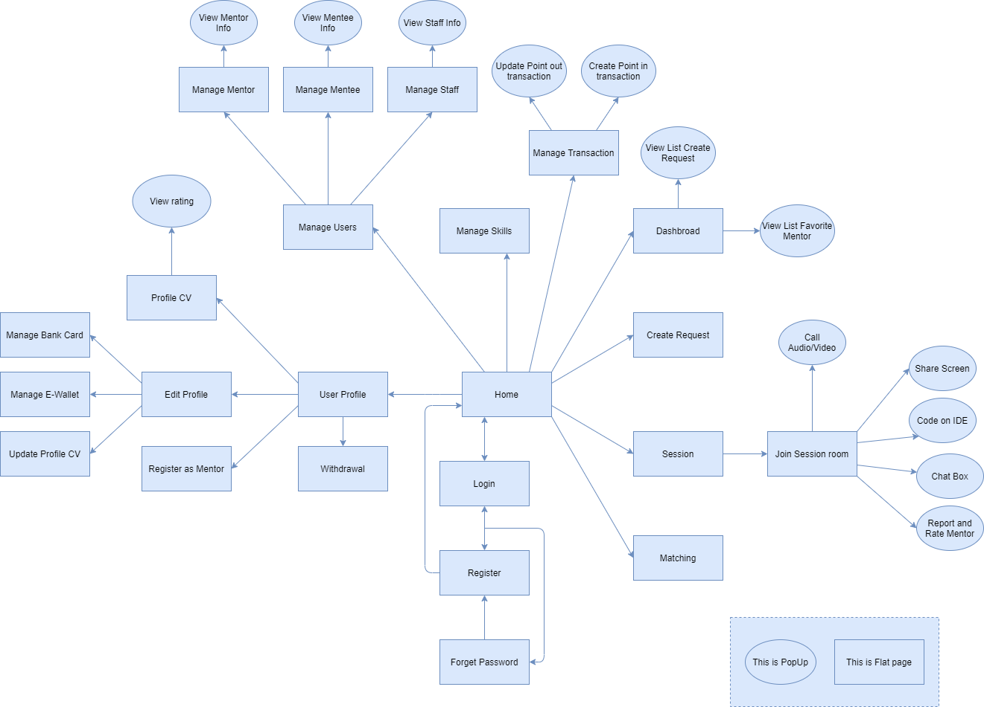

#### b. Screen Details

| **#** | **Feature** | **Screen** | **Description** |
| --- | --- | --- | --- |
| 1 | Home | Sign in | Screen for the user to sign in into the system. |
| 2 | Home | Register | Screen for guests to create an account. |
| 3 | Home | Forgot Password | Screen for the user to find the password. |
| 4 | UserProfile | Home | The screen that shows general information of the website: list online mentors, list requests, list skills, logo, slogan, etc. |
| 5 | UserProfile | Dashboard | The screen for the user to overview the problem. |
| 6 | UserProfile | User Profile | The screen shows useful information. |
| 7 | UserProfile | Edit Profile | The screen where users edit their profiles. |
| 8 | UserProfile | Manage Bank Card | The screen where users manage bank cards. |
| 9 | UserProfile | Register as Mentor | The screen where the mentee register to become a mentor. |
| 10 | UserProfile | View Rating | The popup for users and guests can view the rating and comment of the mentor. |
| 11 | UserProfile | Create Request | The screen for the mentee to create a request. |
| 12 | UserProfile | Session | The screen session for mentee for the mentor. |
| 13 | UserProfile | Join Session Room | The screen of the session room for mentee and mentor. |
| 14 | UserProfile | Rate Mentor | The popup for the mentee to rate mentor after finishing the session |
| 15 | MentorProfile | Matching | The screen matching for the mentee to mentor. |
| 16 | MentorProfile | Share screen | The popup share screen for mentee and mentor. |
| 17 | MentorProfile | Call Video/Audio | The popup call video/audio for mentee and mentor. |
| 18 | MentorProfile | Code on IDE | The popup code on IDE for mentor and mentee. |
| 19 | MentorProfile | Chat Box | The popup chat box for mentee and mentor. |
| 20 | MentorProfile | Update Profile CV | The screen where mentors update their profile-cv. |
| 21 | MentorProfile | Profile CV | The screen where the user can see the profile CV of the mentor |
| 22 | AdminManage | Manage Users | The screen where the admin manages users. |
| 23 | AdminManage | Manage Mentor | The screen where the admin manages mentors. |
| 24 | AdminManage | View Mentor Info | The popup where the admin can view mentor info. |
| 25 | AdminManage | Manage Mentee | The screen where the admin manages the mentee. |
| 26 | AdminManage | View Mentee Info | The popup where the admin can view mentee info. |
| 27 | AdminManage | View Staff Info | The popup where the admin can view staff info. |
| 28 | AdminManage | Manage Skills | The screen where the admin manages skills |
| 29 | StaffManage | Manage Staff | The screen where the admin manages staff. |
| 30 | StaffManage | Manage Transaction | The screen where staff manages transactions. |
| 31 | StaffManage | Create Point in Transaction | The popup where staff creates money in transactions. |
| 32 | StaffManage | Update Point out Transaction | The popup where staff update money out transactions. |
| 33 | AdminManage | View list Created Request | The popup for the mentee view list created a request. |
| 34 | StaffManage | View Point | The popup for the mentee’s point. |

#### c. Screen Authorization

| **Screen** | **Role1** | **Role2** | **Role3** | **Role4** | **Role5** |
| --- | --- | --- | --- | --- | --- |
| Home | X | X | X | X | X |
| Sign in | X | X | X | X | X |
| Register | X |  |  |  |  |
| Forgot Password |  | X | X |  |  |
| UserProfile |  | X | X |  |  |
| Dashboard |  | X | X |  | X |
| Home | X | X | X | X | X |
| User Profile |  | X | X |  |  |
| Edit Profile |  | X | X |  |  |
| Manage Bank Card |  | X | X |  |  |
| Manage E-Wallet |  | X | X |  |  |
| Register as Mentor |  | X |  |  |  |
| View Rating |  | X | X |  |  |
| Create Request |  | X | X |  |  |
| Session |  | X | X |  |  |
| Join Session Room |  | X | X |  |  |
| Rate Mentor |  | X |  |  |  |
| MentorProfile |  |  | X |  |  |
| Matching |  |  | X |  |  |
| Share screen |  | X | X |  |  |
| Call Video/Audio |  | X | X |  |  |
| Code on IDE |  | X | X |  |  |
| Chat Box |  | X | X |  |  |
| Update Profile CV |  |  | X |  |  |
| Profile CV |  |  | X |  |  |
| AdminManage |  |  |  |  |  |
| Manage Users |  |  |  |  | X |
| Manage Mentor |  |  |  |  | X |
| View Mentor Info |  |  |  |  | X |
| Manage Mentee |  |  |  |  | X |
| View Mentee Info |  |  |  |  | X |
| View Staff Info |  |  |  |  | X |
| Manage Skills |  |  |  |  | X |
| StaffManage |  |  |  | X |  |
| Manage Staff |  |  |  | X |  |
| Manage Transaction |  |  |  | X |  |
| Create Point in Transaction |  |  |  | X |  |
| Update Point out Transaction |  |  |  | X |  |
| View list Created Request |  |  |  | X | X |
| View Point |  | X | X | X |  |

In which:

* Role1: Guest
* Role2: Mentee
* Role3: Mentor
* Role4: Staff
* Role5: Admin

#### d. Non-Screen Functions

| **#** | **Feature** | **System Function** | **Description** |
| --- | --- | --- | --- |
| 1 | Home | Sign out | Users sign out of the system. |

#### e. Entity Relationship Diagram

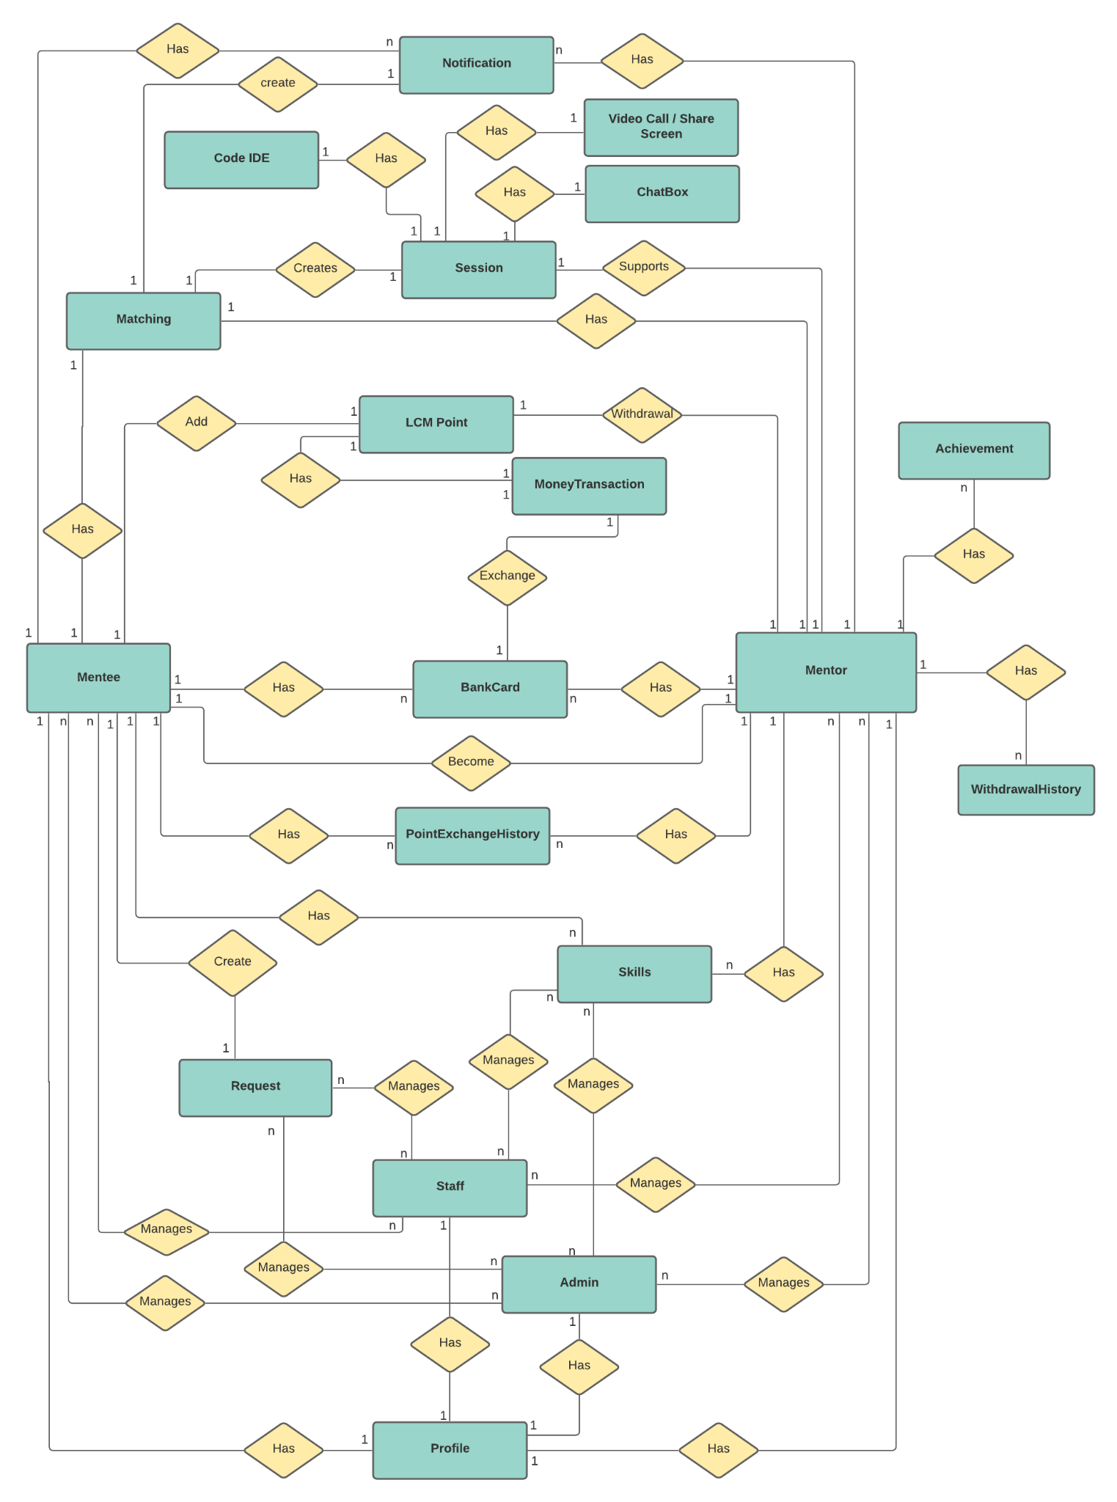

**Entities List**

| **#** | **Entity** | **Description** |
| --- | --- | --- |
| 1 | Notification | The notification of the user in the system. |
| 2 | Code IDE | Code on IDE in Session of mentee and mentor. |
| 3 | Profile | Detail of registered users. |
| 4 | Video Call/ Share Screen | Video Call/ Share Screen in Session of mentee and mentor. |
| 5 | Chax box | Chat box in Session of mentee and mentor. |
| 6 | Session | The Session of mentee and mentor |
| 7 | Matching | Mentor selects a question to match with the mentee. |
| 8 | LCM point | The point of LCM |
| 9 | Money Transaction | The money in transaction |
| 10 | Achievement | The achievement of the mentor. |
| 11 | BankCard | The bank card of the user |
| 12 | WithdrawalHistory | The withdrawal history. |
| 13 | Mentee | The mentee of the LCM system. |
| 14 | Mentor | The mentor of the LCM system. |
| 15 | PointExchangeHistory | The point exchange history |
| 16 | Skills | The tag skills. |
| 17 | Request | The request of mentee |
| 18 | Staff | The staff of the LCM system |
| 19 | Admin | The admin of the LCM system |

### 3.2 Home

#### a. Sign in

* *Function trigger: This function is triggered when the user clicks Sign in from Homepage*
* *Function description: User sign in into the system.*
* *Screen layout: mock-up prototype of the screen, sample below is for the Sign in screen.*

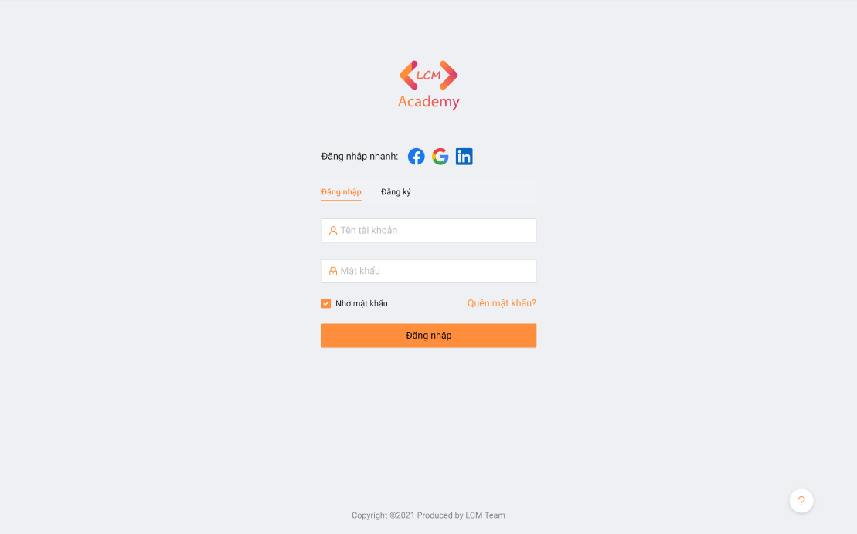

* *Function Details: When the user is in the state not logged in, at the home page there will be a Sign in button after sign in into the system, the Sign in button will become Sign out.*

#### b. Manage Skills

* *Function trigger: This function is triggered when the user clicks Sign in from Homepage*
* *Function description: The admin manages skills such as delete skills, update skills, ...*
* *Screen layout: mock-up prototype of the screen, sample below is for the Manage Skills.*

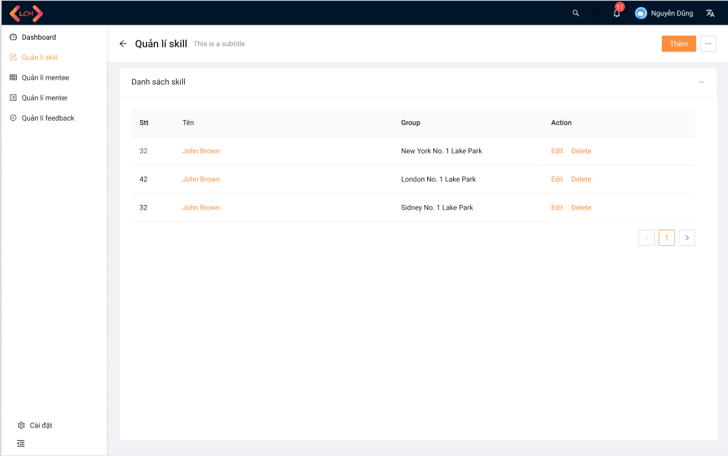

* *Function Details: After sign in, the admin selects Manage Skills, here the admin will add, edit, delete or update skills.*

#### c. Create Request

* *Function trigger: This function is triggered when the mentee clicks Create Request from the Homepage.*
* *Function description: The mentee created a question to ask the mentor.*
* *Screen layout: mock up a prototype of the screen, the sample below is for the Create Request.*

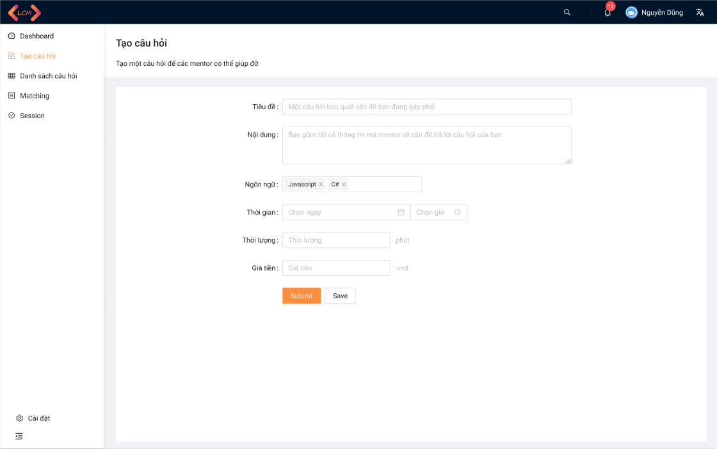

* *Function Details: After sign in, the mentee selects Create Request, here the mentee will input into fields and chooses the programming language, ...*

#### e. Session

* *Function trigger: This function is triggered when the Mentee requests to start the session with the mentor.*
* *Function description: The mentee and mentor start the session.*
* *Screen layout: mock-up prototype of the screen, sample below is for the Manage Skills.*

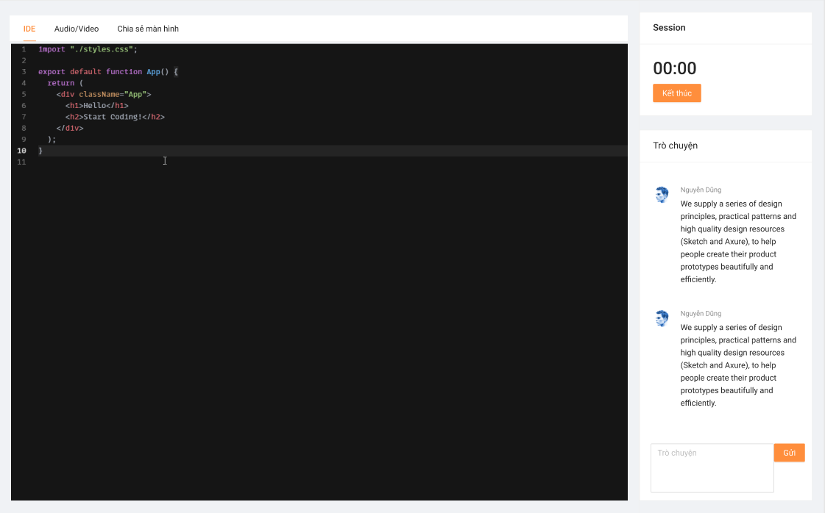

* *Function Details: After matching together, the mentee and mentor will create a session to resolve the problem of the mentee.*

#### f. Matching

* *Function trigger: This function is triggered when the Mentor chooses the question of mentee.*
* *Function description: Mentor choose questions of mentee by skill.*
* *Screen layout: mock-up prototype of the screen, sample below is for the Manage Skills.*

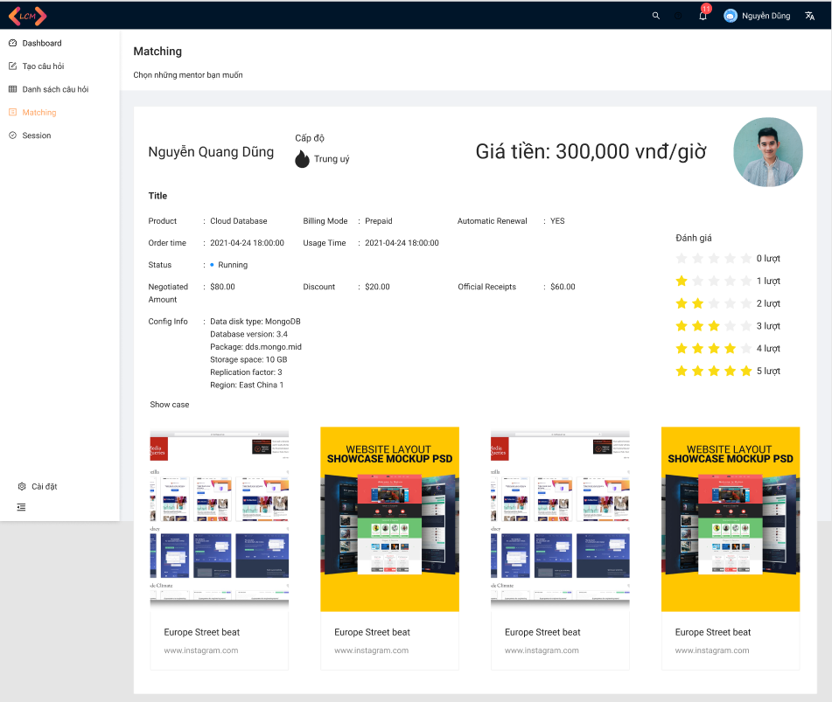

* *Function Details: After matching with the mentor, the mentee can see the information of the mentor who just matched.*

#### g. View All Mentor

* *Function trigger: This function is triggered when the guest chooses View All Mentors on the Homepage*
* *Function description: The mentee views all mentors of LCM.*
* *Screen layout: mock-up prototype of the screen, sample below is for the View All Mentor.*

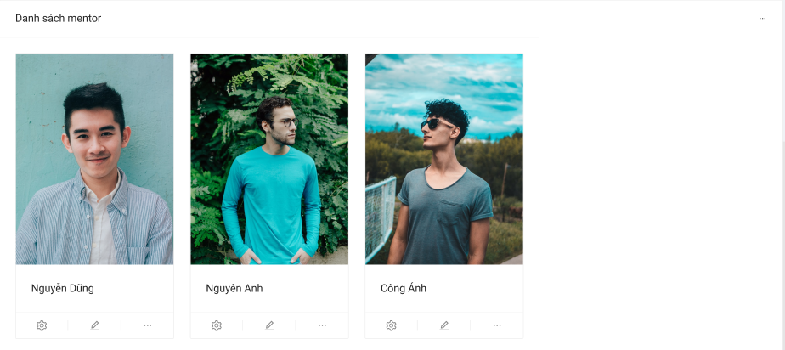

* *Function Details: After going to the homepage, guests can see a list of all mentors.*

#### h. View All Category

* *Function trigger: This function is triggered when the guest goes to the Homepage*
* *Function description: The guest can see all categories*
* *Screen layout: mock-up prototype of the popup, sample below is for the View All Categories.*

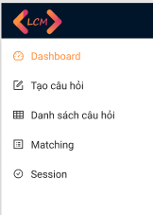

* *Function Details: After going to the homepage, guests can see a list of all categories.*

### 3.3 User Setting

#### a. User Profile

* *Function trigger: This function is triggered when the user chooses to see Profile*
* *Function description: The user can view their profile.*
* *Screen layout: mock-up prototype of the screen, sample below is for the User profile.*

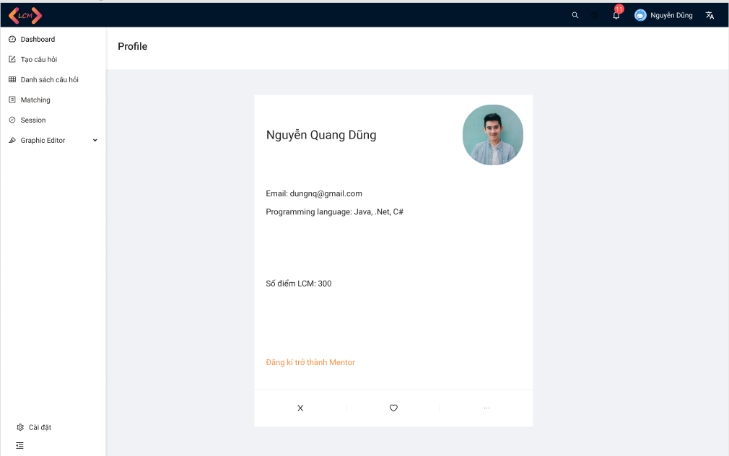

* *Function Details: After login into the system, user can see their profile.*

#### b. Register as Mentor

* *Function trigger: This function is triggered when the user chooses to become a mentor.*
* *Function description: The user register to become a mentor.*
* *Screen layout: mock-up prototype of the screen, sample below is for the Register as Mentor.*

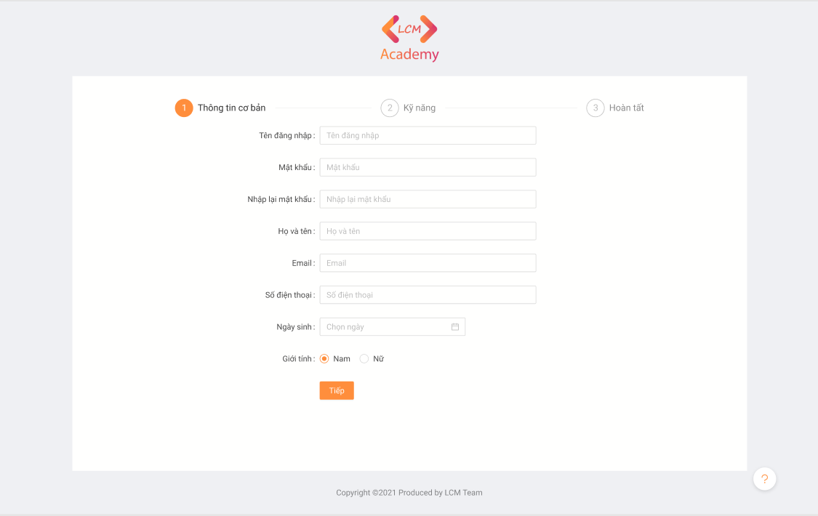

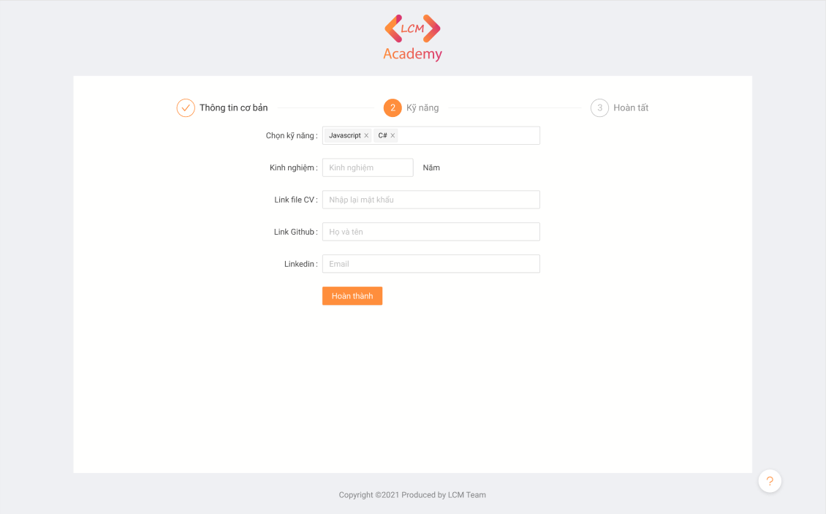

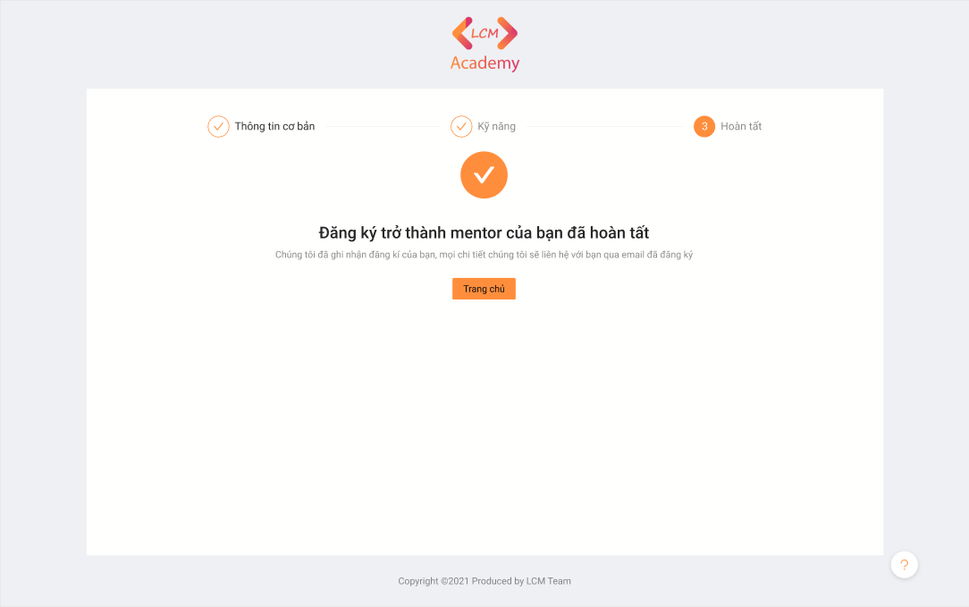

* *Function Details: The user input all the fields to provide information then choose “Hoàn thành”.*

#### c. View All Category

* *Function trigger: This function is triggered when the guest go to the Homepage*
* *Function description: The guest can see all categories*
* *Screen layout: mock-up prototype of the screen, sample below is for the View All Categories.*
* *Function Details: After going to the homepage, guests can see a list of all categories.*

### 3.4 Mentor Info

#### a. Profile CV

* *Function trigger: This function is triggered when the user or guest chooses to view Mentor’s Profile CV.*
* *Function description: The user or guest can view the Profile CV of the Mentor.*
* *Screen layout: mock-up prototype of the screen, sample below is for the Profile CV.*

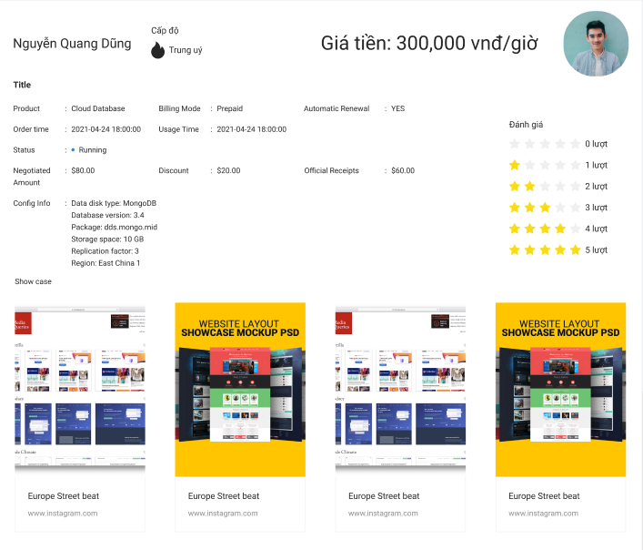

* *Function Details: User or guest can view the Profile CV of Mentor.*

#### b. View Comment and Rating of User

* *Function trigger: This function is triggered user view Profile CV of Mentor*
* *Function description: The user and guest can view rating and comment of men*
* *Screen layout: mock-up prototype of the screen, sample below is for the View Rating and Comment of Mentor.*

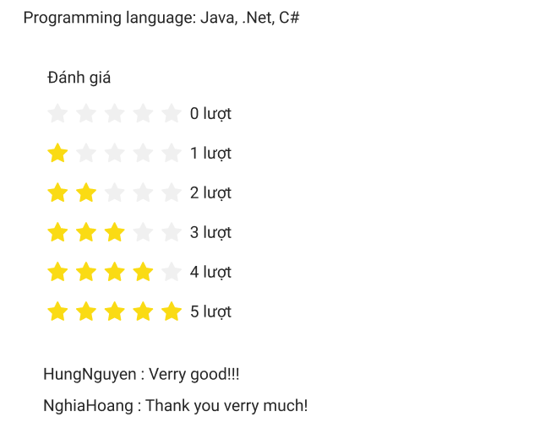

* *Function Details: Guest and users can see the comment and rating of the mentor.*

### 3.5 Manage Mentee

#### a. Manage Mentee

* *Function trigger: This function is triggered when the admin chooses to manage Mentee.*
* *Function description: The admin manages Mentee.*
* *Screen layout: mock-up prototype of the screen, sample below is for the Manage Mentee.*

*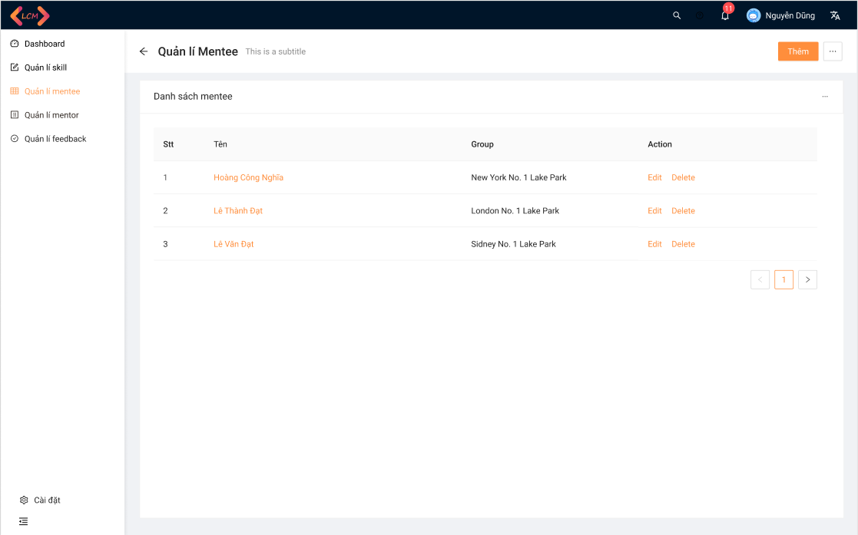server*

* *Function Details: After go to the homepage admin can choose to manage Mentee.*

#### b. View Mentee Info

* *Function trigger: This function is triggered when the admin view mentee info*
* *Function description: The admin can view mentee info*
* *Screen layout: mock-up prototype of the screen, sample below is for the View Mentee Info.*

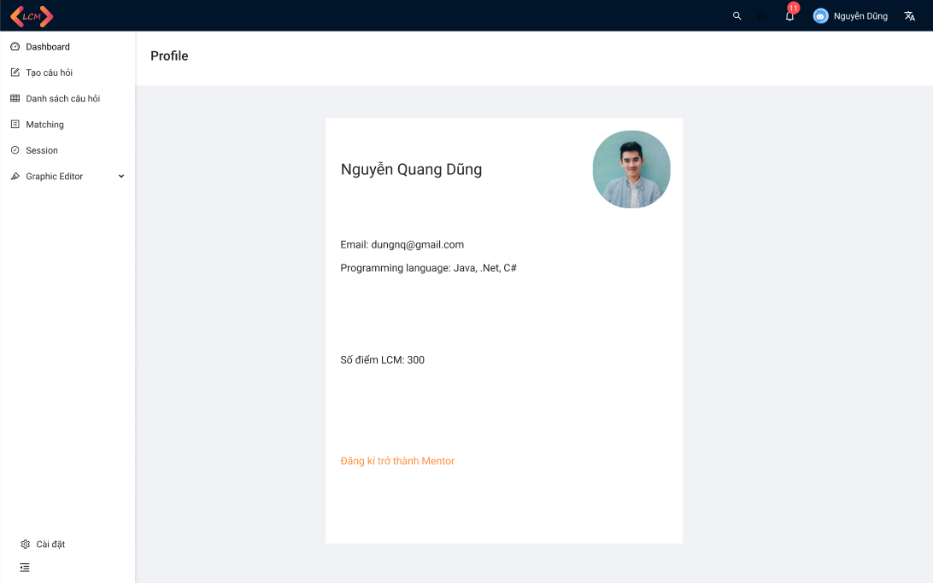

* *Function Details: Admin view profile of mentee.*

### 3.6 Manage Mentor

#### a. Manage Mentor

* *Function trigger: This function is triggered when the admin chooses to manage Mentor.*
* *Function description: The admin manages Mentor.*
* *Screen layout: mock-up prototype of the screen, sample below is for the Manage Mentor.*

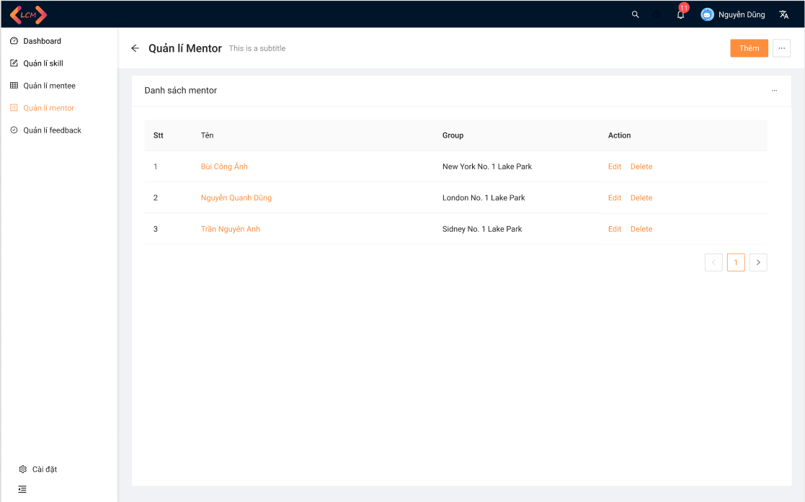

* *Function Details: After go to the homepage admin can choose to manage Mentee.*

#### b. View Mentor Info

* *Function trigger: This function is triggered when the admin view mentor info*
* *Function description: The admin can view mentor info*
* *Screen layout: mock-up prototype of the screen, sample below is for the View Mentor Info.*

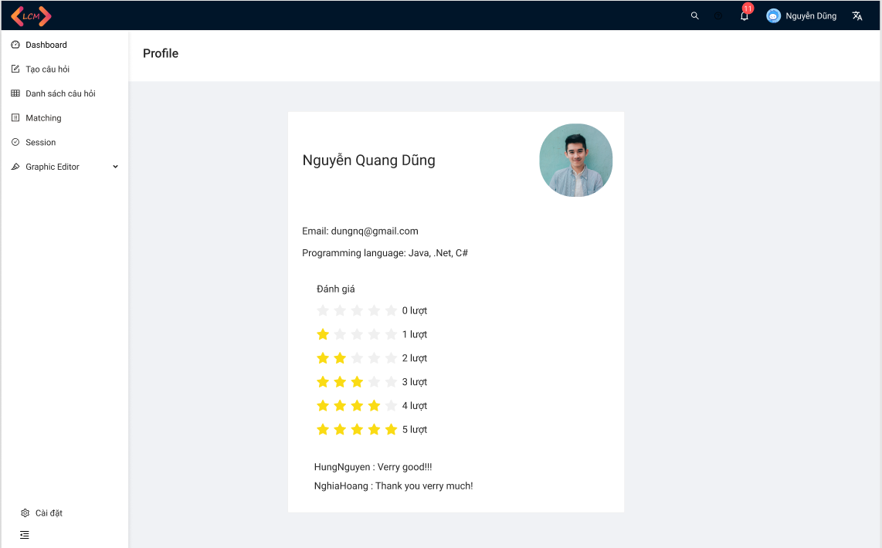

* *Function Details: Admin view mentor profile.*

### 3.7 Dashboard

#### a. View List Created Request

* *Function trigger: This function is triggered when the mentee created a request then views the list created request.*
* *Function description: The mentee view list created was requested.*
* *Screen layout: mock-up prototype of the screen, sample below is for the View List Created Request.*

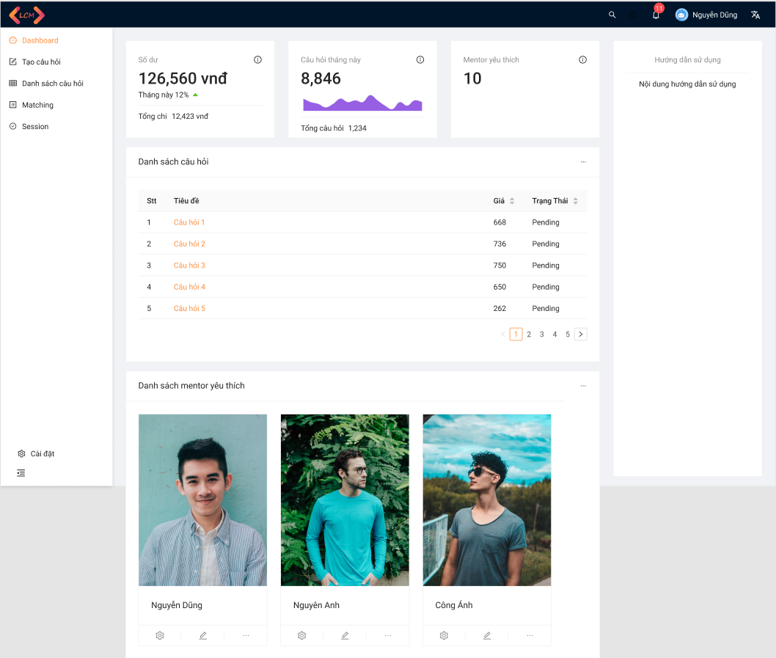

* *Function Details: After going to the homepage, in the dashboard mentee can view the list created request.*

### 3.8 Join Session Room

#### a. Share screen

* *Function trigger: This function is triggered when the mentor and mentee join the session.*
* *Function description: The mentor and mentee can share the screen.*
* *Screen layout: mock-up prototype of the screen, sample below is for the Share screen.*

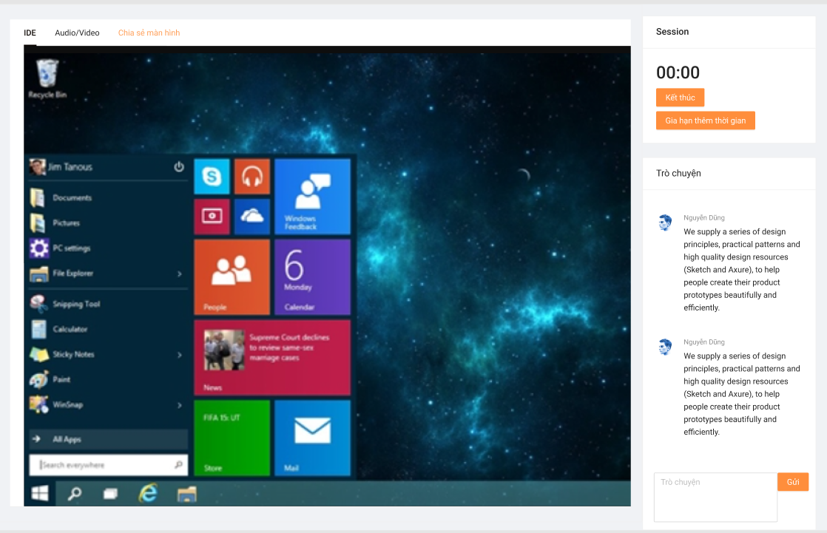

* *Function Details: After joining the session mentor and mentee and mentee can share the screen.*

#### b. Call Audio/Video

* *Function trigger: This function is triggered when the mentor and mentee join the session.*
* *Function description: The mentor and mentee can call audio/video.*
* *Screen layout: mock-up prototype of the screen, sample below is for the Call Audio/Video.*

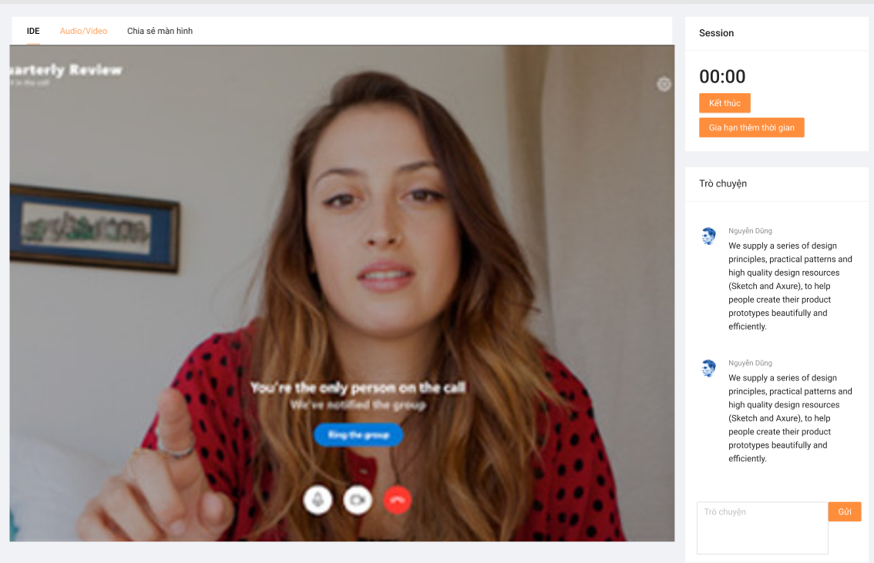

* *Function Details: After joining the session mentor and mentee and mentee can call Audio/Video.*

#### c. Code on IDE

* *Function trigger: This function is triggered when the mentor and mentee join the session.*
* *Function description: The mentor and mentee can code on IDE.*
* *Screen layout: mock-up prototype of the screen, sample below is for the Code on IDE.*

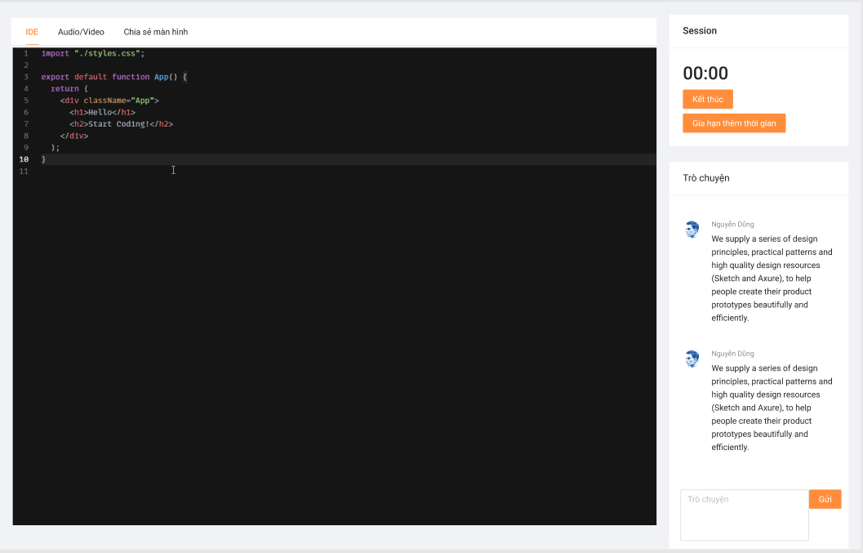

* *Function Details: After joining the session mentor and mentee and mentee can code on IDE..*

#### a. Chat Box

* *Function trigger: This function is triggered when the mentor and mentee join the session.*
* *Function description: The mentee and mentor can chat together.*
* *Screen layout: mock-up prototype of the screen, sample below is for the Chat Box.*

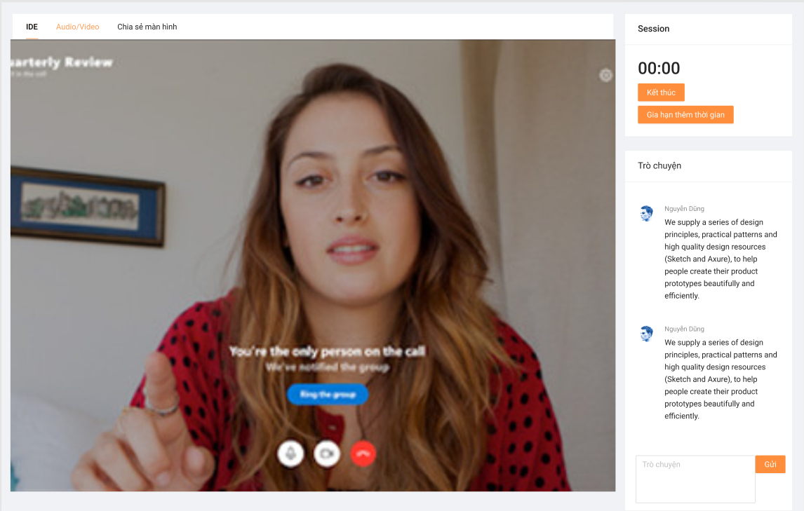

* *Function Details: After joining, the session mentee and mentor can chat together by chatbox.*

### 3.6 Register

* *Function trigger: This function is triggered when the guest goes to Homepage and choose to register*
* *Function description: The guest can create an account.*
* *Screen layout: mock-up prototype of the screen, sample below is for the Register.*

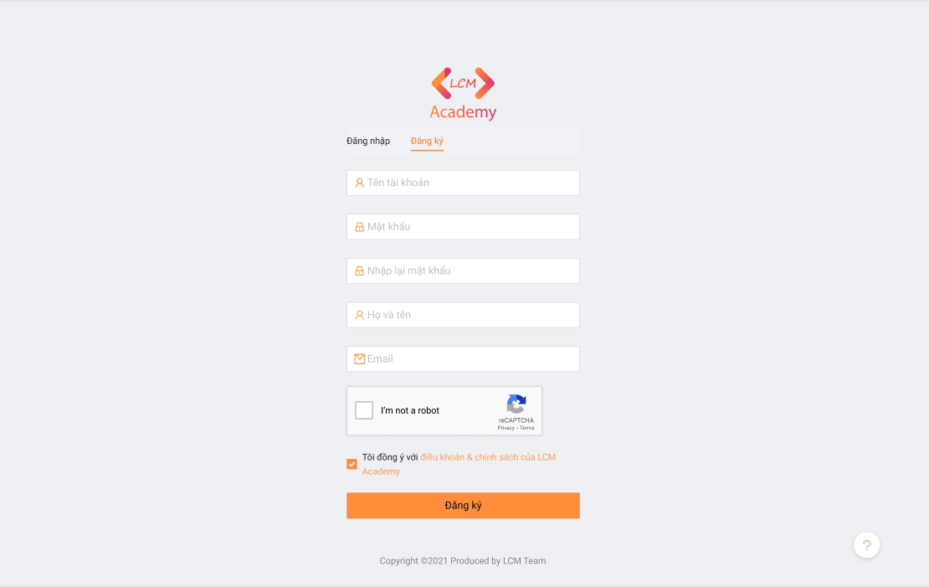

* *Function Details: After going to the homepage, the guest can create an account.*

## 4. Non-Functional Requirements

### 4.1 External Interfaces

#### a. User Interfaces

UI-1: The websites will have a user-friendly interface and are easy to use.

UI-2: The layout of the screen is streamlined, easy to operate, and implement for the user.

UI-3: Buttons have distinctive features and colors but are in sync with the interface.

UI-4: When the user is on a screen or function, the position of that function displayed on the sidebar will be bright and synchronized with the interface.

UI-5: Notifications displayed on the screen have a friendly banner outlining the content for the user.

UI-6: The LCM screen displays shall conform to the Process Impact Internet Application User Interface Standard, Version 2.0 [3].

UI-7: The system will provide a website help link that is displayed explaining how to use that page to the user.

UI-8: Web pages will allow users to copy and paste using a mouse, in addition to using a mouse and keyboard combination.

#### b. Software Interfaces

SI-1: Login System

SI-1.1: The LCM will pass the username and password of the user to the sign-in system through a programming interface.

SI-1.2: The sign-in system will notify LCM that the user exists or not.

SI-1.3: When the sign-in system notifies LCM that the user exists or does not exist, LCM will take the user to the homepage or send a notification that the user does not exist.

SI-2: Manage System

The LCM shall communicate with the Manage System through a programmatic interface for the following operations:

SI-2.1: To allow an Admin to view all Users.

SI-2.2: To allow an Admin to view all Mentors.

SI-2.3: To allow an Admin to view all Requests.

SI-2.4: To allow an Admin to view all Skill.

SI-2.5: To inquire whether an Admin creates, updates, server or deletes skills.

SI-3: Payment System

SI-3.1: LCM will give the amount of one LCM point for user reference through the Payment System.

SI-3.2: The Payment system will allow users to top up their account then notify the LCM.

SI-3.3: After recharging an account via the Payment System, users can buy LCM points.

SI-3.4: After changing the LCM point to the Payment System, the LCM point number of the user will be updated by the LCM.

#### c. Hardware Interfaces

No hardware interfaces have been identified.

#### d. Communications Interfaces

CI-1: The LCM shall send an email or text message (based on user account settings) to the Patron to confirm acceptance of forgotten password.

CI-2: The LCM provides mentees and mentors with a chat box to communicate with each other.

### 4.2 Quality Attributes

#### a. Usability

* The language is Vietnamese and English.
* The user interface of the solution should be elegant, easy to navigate, and user-friendly
* All the titles or names of functions should be easy to understand and reflect the purpose of the function.
* All error message should be clear for all users
* All related functions for each type of user should be grouped into categories and placed on a navigation bar for the efficiency of interactions.
* User should be able to learn to use the specified functions in no time
* Links, buttons are easily clickable.
* Links are easily recognizable, which looks clickable.
* Main functions are organized into tabs for easier access.
* Links, buttons, and checkboxes are easily clickable.
* The Front-end web application should support Chrome and Firefox browsers.

#### b. Reliability

* The system function is carefully observed and learned from the actual needs of users (mentee, mentor) and the LCM's demand.
* The average time it takes to repair the system if a module fails is about 4-8 hours.
* The system is only allowed to stop working for at most 8 hours since the problem occurred so that users can continue using the system.

#### c. Performance

* The Front-end system uses ReactJS which makes writing Javascript code easier because it uses a special syntax that is JSX syntax.
* The Back-end system uses NodeJS which is a platform that runs on the V8 JavaScript runtime - a very fast JavaScript interpreter that runs on the Chrome browser.

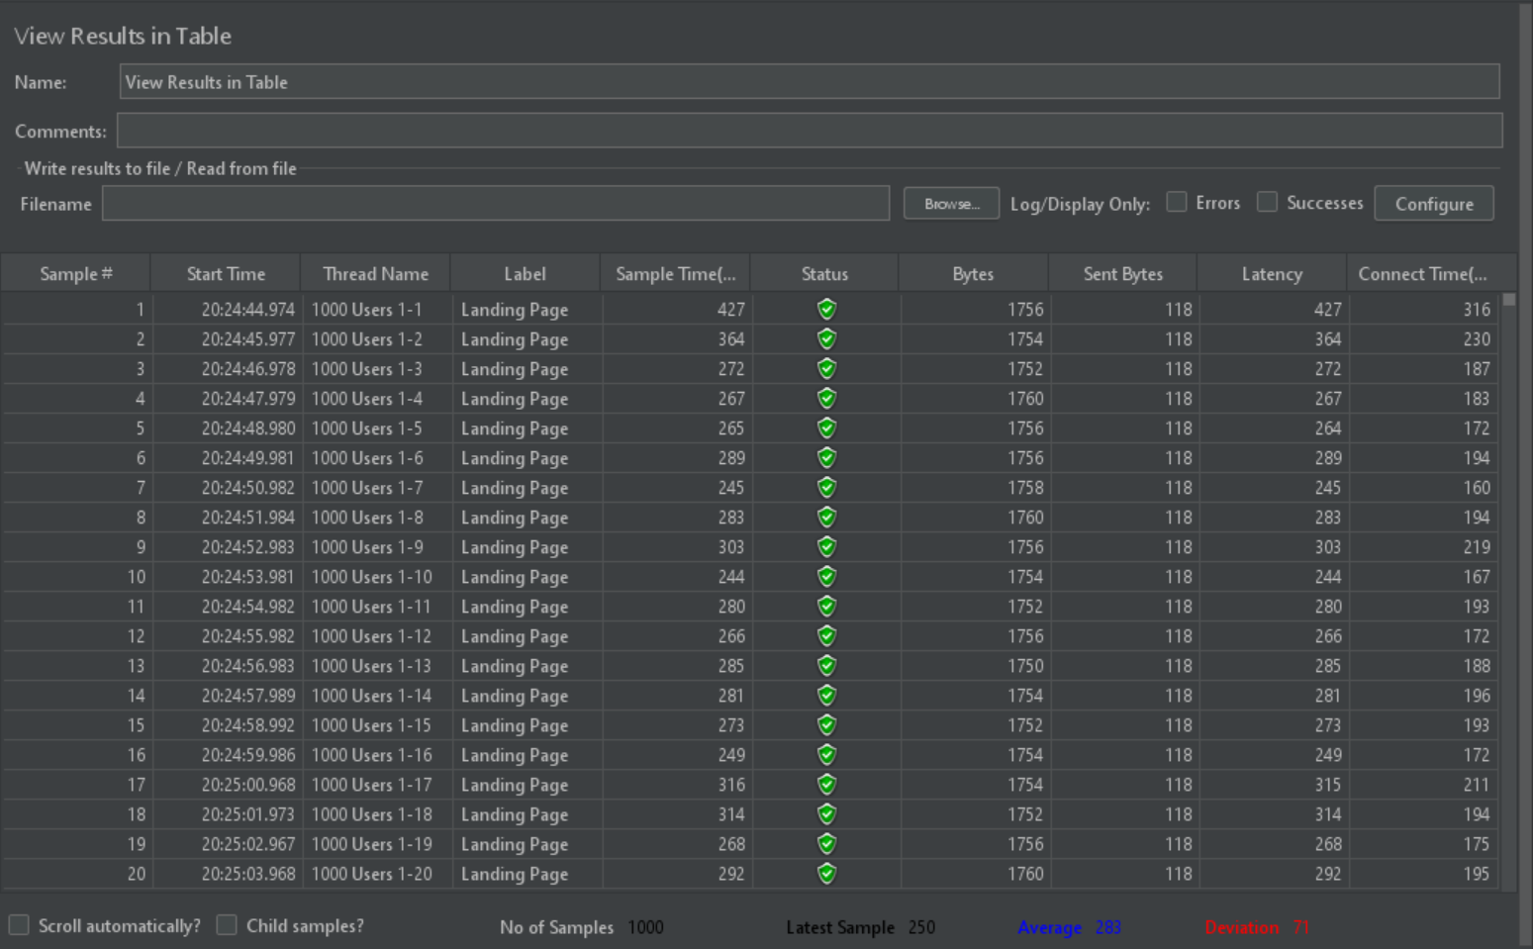

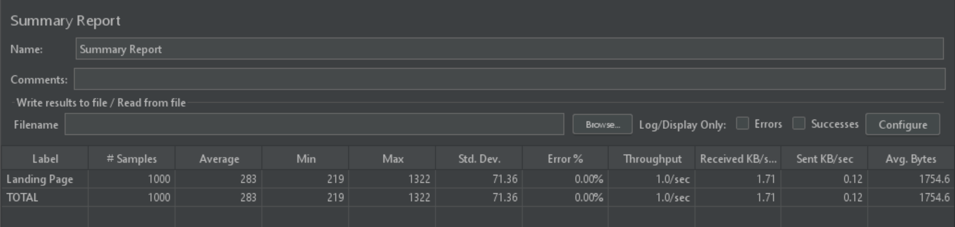

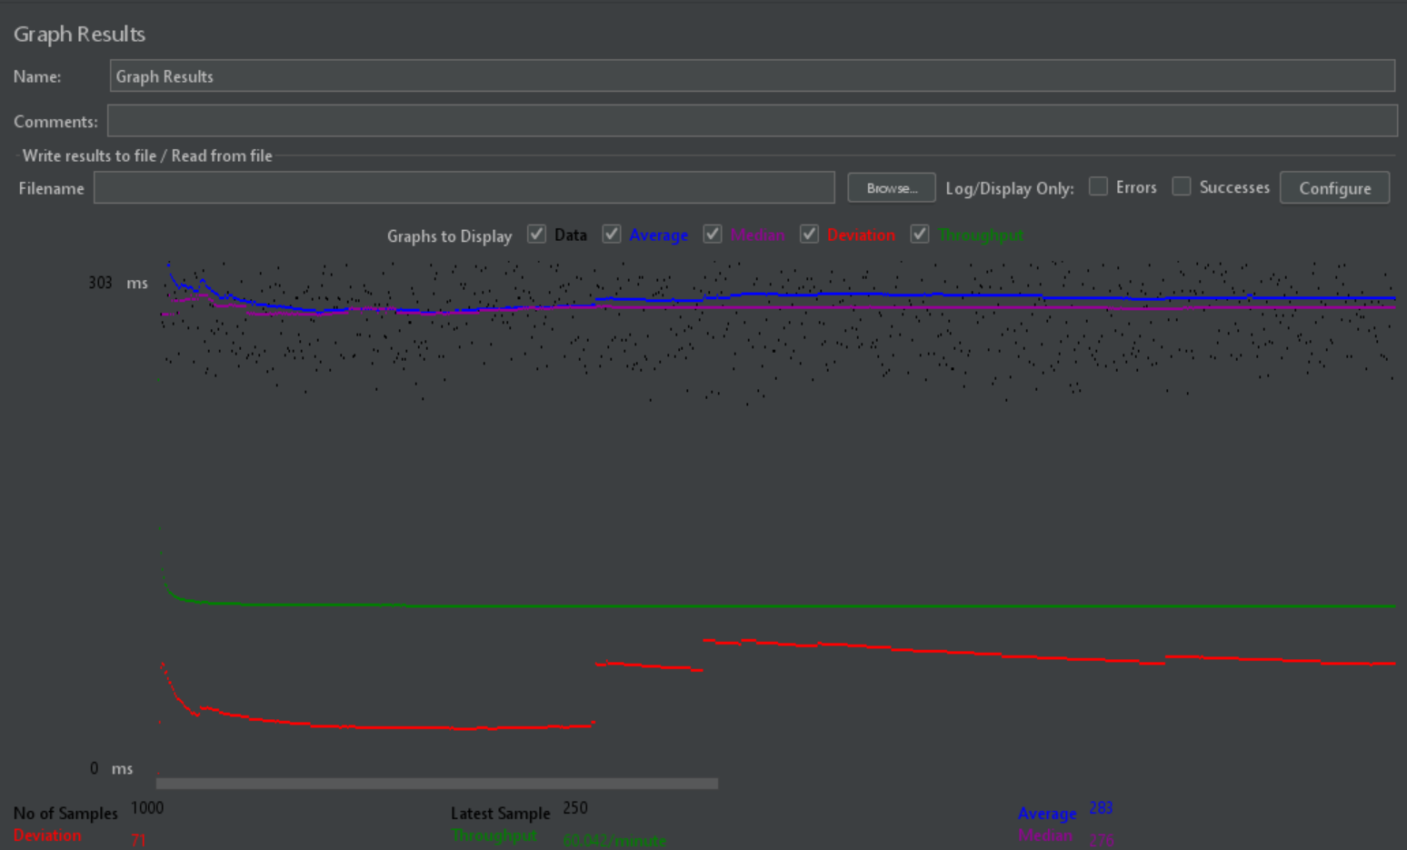

The results obtained when analyzing the results from the listeners with the Landing Page scenario:

* It can be seen that initially when the number of users is increasing, the response time of the server is quite fast, only about 1 second, and when the fixed number of users is 1000 people visit the homepage, children. this number falls to about 0.283s. The number of successful requests made increases slowly as the number of users increases and then very steadily (these lines are drawn next up on).
* The website's throughput after testing is 60,042 / minutes which means that the server processes 60,042 requests per minute
* The deviation of the website after the test is 72 it shows that the current deviation from the average is very low.
* The number of error transactions is only 0.00%, showing that the website works very well.
* The average response time value is 283ms

#### d. Dependability

##### d1. Security

* The system must use token-based authentication, in which the authentication server returns an access token after the user logged in with username/email and password. Then the client will include the access token in the subsequent requests to access protected resources. Using token-based authentication brings a lot of benefits to the system including:
* Allow cross-domain requests.
* Stateless, which improves the scalability of the system.
* Allow the separation between front-end and back-end sides. The front-end can be developed as standalone client applications (web, mobile, etc.), while the back-end provides APIs for client consumption.
* All passwords must be hashed using the BCrypt algorithm with at least 10 salt rounds.

##### d2. Safety

* This product is a web application running on the web browser so it will not affect any other application or user’s hardware, which may lead to data loss or system damage. The software is designed mainly for devices with an appropriate wide display so for maintaining the correctness of the user’s actions and data, the user should use this application on a device with a wide enough screen so the software can fit the screen.
* However, the solution is an e-commerce application so all transactions and behavior must follow the Law on Commerce of Vietnam No.36/2005/QH11 and Decree No.52/2013/NĐ-CP About eCommerce

#### e. Supportability

* The system will have maintenance periods to improve user security.
* The system will update content updates for users.
* The system has counselors to support mentees and mentors if they have any problems.

#### f. Design Constraints

- End-user’s Environment: Windows.

- Support languages: Vietnamese, English.

- Web application must be responsive and snappy.

- The user must have a stable connection to the internet.

#### g. Support Documents

- LCM User guides

## 5. Other Requirements

### 5.1 Appendix1 - Notification List

| **#** | **Notification code** | **Notification Type** | **Context** | **Content** |
| --- | --- | --- | --- | --- |
| 1 | NOT01 | Request | The user does not enter information in the fields | *Fields cannot be blank.* |
| 2 | NOT02 | Request | The user enters information in one field, leaving the remaining fields blank. | *Fields cannot be blank.* |
| 3 | NOT03 | Request | User input correct format of Username, Password, Re-password, Full name, Email | *Register Successfully.* |
| 4 | NOT04 | Request | Username already exists | *Show message "Username has already existed.* |
| 5 | NOT05 | Request | User input email does not contain the character "@". | *Email must contain one character @.* |
| 6 | NOT06 | Request | User input Re-password contains special characters such as:! @ # $ | *Passwords do not contain special characters such as: “! @ #$”.* |
| 7 | NOT07 | Request | Register successfully | *Register Successfully.* |
| 8 | NOT08 | Request | Input Password’s length between 8 to 24 characters | *Password’s length between 8 to 24 characters.* |